City of Hilliard
3800 Municipal Way
Hilliard, Ohio 43026
Sealed bids will be accepted in the above office until
July 30th 2019 at 11 am EST

For
Request for Proposals
Fiber Optic Backbone, Engineering, Design, and Services
NOTICE
PROPOSALS DUE: July 30th 2019 at 11 am EST
PROJECT NAME: Fiber Optic Network
PROJECT LOCATION: City of Hilliard, Ohio
PROJECT DESCRIPTION: Engineering of fiber optic network in the West end of Franklin County, which will be utilized to facilitate connectivity between the City of Hilliard Municipal Buildings and surrounding governmental agencies.

Exhibit 1 for Fiber Map
Exhibit 2 for Fiber Network Routes.

City Of Hilliard Address:
3800 Municipal Way
Hilliard, Ohio 43026
Franklin County

Main Contact:
Duane Powell, Director of Information Technology
Email: dpowell@hilliardohio.gov
Main Phone Number: 614-334-2594

The City Of Hilliard is seeking a Request for Proposal (RFP) for the purpose of contracting with a qualified firm or firms to provide a detailed location audit and planning and design for the eventual construction of a single-mode fiber network interconnecting multiple locations within Western Franklin County as outlined within this document. See Exhibits. This RFP is for network planning ONLY. An additional RFP will be issued to cover the build portion based on the information learned from this work effort.

This RFP is divided into two sections for bid responses. These sections are listed as follows –
Section 2A: General routing, Engineering and Field Survey with GPS,
Section 2B: Alternate Vendor Proposals.

Table of Contents
GENERAL REQUIREMENT: 3
Section 1: GENERAL INFORMATION 3
Section 2: SCOPE OF WORK 3
Section 2A: Dark Fiber Design 4
Section 2C: Alternate Vendor Proposals 9
Section 3: Project Pricing 9
3.1 Cost by Segment for Proposed Primary Fiber Optic Network Routes 9
3.2 Cost by Segment for Proposed Secondary Fiber Optic Network Routes 10
4.0 Required Contract Terms 11
REFERENCES 13
AUTHORIZED NEGOTIATORS: 13
PROPOSER'S CERTIFICATION 16

GENERAL REQUIREMENT:
This is a Request for Proposal. Proposal will be opened and evaluated in private and proposal information will be kept confidential until an award is made. One (1) original and one (1) copy of the complete proposal are to be submitted. Four (4) copies of electronic version of the proposal should also be submitted in Adobe Acrobat or Microsoft Office readable format.

Section 1: GENERAL INFORMATION

CRITERIA for SELECTION

The City desires to procure the professional services of an experienced fiber optic network construction firm or project team most qualified and best suited to provide the services described in this Request for Proposal. The vendor evaluation will be based on the following criteria:

Proposed Solution
Vendors must demonstrate their understanding and knowledge of the City's requirements and propose either a comprehensive solution for all components of the RFP or complete approaches to each RFP section addressed by the vendor proposal. The proposed solution should be based on a proven methodology and include a detailed and realistic project plan. (35 Points)

Network Design and Technical Expertise
Vendors must present their qualifications and expertise with the design, and engineering, of comparable fiber networks for each component of the RFP to which you respond. (15 Points)

Cost Proposal
Vendors must provide a cost effective solution for the City, including design, estimated construction costs and projected ongoing operational costs. (35 Points)

Prior Experience and References
Vendors must demonstrate proven experience with the City's requirements based on comparable reference sites in size and complexity as the City's project. (15 points)

Total 100 points

Section 2: SCOPE OF WORK

Executive Summary
The City of Hilliard (City) is requesting proposals from qualified Providers to design a next generation communications fiber network ("Network") that will provide first-rate internet access services and network connectivity for the City of Hilliard. A baseline of hundred (100) Gbps symmetric service will serve as the definition of "next generation" services for this RFP.

This fiber network will provide access to the high capacity network provisioned by the City of Hilliard. The City is seeking to implement a fiber optic infrastructure between multiple secondary sites serving municipal, school, authority, township and other local facilities. The City will implement an Ethernet distribution system across the established fiber network with a minimum of one (1) pair placed into service for an Ethernet Data Transport Backbone.

Section 2A: Dark Fiber Design

Fiber Backbone
The City desires to have a minimum of two hundred eighty-eight (288) strand single mode fiber optic network consistent with exhibit 1A. Twelve (12) and twenty-four (24) strand single mode fiber optic cables may be used for laterals and entrance cables. Twelve (12) AWG coated copper tracer wire may be placed in all underground sections for locating purposes. One hundred fifty feet (150’) slack loops will be installed along cable route every twelve-hundred to fifteen-hundred feet(1200-1500’). Aerial storage shall utilize snowshoes.

Secondary Fiber Laterals
Additionally the City desires to provide fiber connectivity to seven public sector locations including municipal, school, authority, township and other local facilities. These additional locations will be served as laterals from the primary backbone cable with twenty-four (24) strand (minimum) single-mode fiber optic cable. The exception to this is City Hall and JSSB which will be the primary and secondary termination points for the Cities fiber network and act as the meet me point for all external service provider partners.

Public Private Partnership
The City may seek private investment or the lease of the fiber optic infrastructure to leverage available resources. The City seeks to serve the maximum number of commercial sites possible. In addition to municipal, school, authority, township locations in order to lower the long term cost of maintenance and operations of the network, and establish the framework to expand the network to addition communities and sites as resources become available. This network must be designed with enough pairs to serve the city, schools, authority, township on their own dedicated fiber networks as designed in final engineering.

Project Management
Qualified Providers will provide a dedicated project manager to manage the fiber network design and engineering of the fiber network. The Project Manager will provide weekly updates throughout the engineering stage of the fiber network design and identify all costs including any make ready work necessary. The Project Manager will provide all as design drawings in electronic GIS compatible and paper form. The paper hardcopy of the network design shall be included in a binder in a neat and professional manner.

Design
The City fiber map identifies the primary anchors sites to be served with the fiber system and a highway based path to facilitate routing of the fiber cabling. The City will entertain alternate fiber routes. The selected firm will verify continuity for the fiber path or modify fiber path to avoid obstacles and obstructions. This project shall validate the proposed route and identify any make ready improvements and cost required to complete each fiber segment. The design will also require site surveys to determine status and any potential issues with proposed anchor or secondary lateral sites. The proposed locations for hand holes, slack spans, and potential aggregation point for expansion of the network will also be outlined during the design.

Engineer
From the attached city provided documents, the vendor will generate construction ready documentation providing running line detail, identifying key obstructions and potential issues and providing construction level detail required for state, local and regional permitting. Qualified Providers will provide engineering services for both the underground and aerial portions of the route. Services will include pole sticking and load analysis (when required), aerial and underground route mapping in CAD with profile views, and right-of-way agreements in needed. In addition, inventory of existing City owned conduit to include all pull boxes, fiber cabinets, occupancy (if applicable) and verification conduit is clear of debris or obstruction. Please review the city-owned conduit assets in Exhibit 3 for reference. Interconnect with pre-exsiting aerial fiber on Cemetery Rd design options with further detail provided in Exhibit 4 PDF attachment.

.

Primary Fiber Construction:

See Attachment 1 (Fiber Map)

Please review the fiber map (.kmz Google Earth file) for detailed routes. These are backbone routes.

Name | From | To | Est Distance Ft
Main St 1 | 40’0211.78 – 83’.0922.84 | 40’.0156.95 – 83’.0940.54 | 2051
Cemetary 4 | 40’0156.41 – 83’0805.08 | 40’0157.37 – 83’0751.72 | 1067
Britton Pkwy 2 | 40’0341.81 – 83’0814.19 | 40’0405.81 – 83’0812.69 | 2753
Cemetary Rd 2 | 40’0200.40 – 83’0720.05 | 40’0200.96 – 83’0703.51 | 1304
Cemetary Rd 5 | 40’0157.98 – 83’0744.99 | 40’0200.33 – 83’0719.99 | 1961
Northwest Pkwy | 40’0215.88-83’0922.98 | 40’0218.41-83’0824.20 | 4606
Main St | 40’0147.90-83’0940.41 | 40’0156.81-83’0940.46 | 940
Center St | 40’0201.97-83’0934.52 | 40’0208.14-83’0943.48 | 943
Cemetary Rd | 40’0157.44-83’075156 | 40’0157.95-83’0744.82 | 518
Cemetary Rd 3 | 40’0148.02-83’0940.15 | 40’0150.55-83’0904.29 | 2829
Trueman Blvd | 40’0303.30-83’0730.39 | 40’0201.04-83’0703.76 | 7043
Leap rd | 40’0218.56-83’0824.39 | 40’0154.33-83’0824.15 | 2560
Britton Pkwy | 40’0341.23-83’0814.91 | 40’0157.27-83’0753.04 | 10730
East Pool | 40’0259.75-83’0802.00 | 40’0244.15-83’0715.50 | 5624
Mill Run | 40’0200.97-83’0703.50 | 40’0123.23-83’0720.02 | 7858
Leap Rd to Britton | 40’0218.53-83’0824.36 | 40’0230.06-83’752.48 | 3444
Hilliard Rome Rd | 40’0148.02-83’0940.12 | 40’0013.20-83’0914.58 | 10365
Hilliard Tech Park | 40’0225.36-83’0821.93 | 40’0219.20-83’0752.16 | 2690
Freeway Bus Park | 40’0157.24-83’0752.74 | 40’123.12-83’0720.21 | 5286
East Hill Acres | 40’0154.43-83’0824.00 | 40’0156.37-83’0804.76 | 5624
Scioto Darby W | 40’0158.94-83’1042.08 | 40’149.72-83’0952.74 | 4198
Scioto Darby E | 40’0149.72-83’0952.85 | 40’0147.96-83’0940.45 | 1020

Total estimated length of two hundred eighty-eight (288) strand Back bone cable is (85,414 feet) 16.17 miles.

The following table lists the secondary fiber path components addressed by this RFP. These fiber laterals will be constructed with twenty-four (24) and twelve (12) strand single-mode fiber optic cables. Distances are estimated.
Secondary ( Lateral) Fiber Construction Sites:
Name |  |  | From |  | To |  | Distance
Rec Center Lat |  |  | 40’0155.08-83’1004.69 |  | 40’0144.22-83’1005.56 |  | 1426
Incubator Lat |  |  | 40’0301.71-83’0746.19 |  | 40’0250.21-83’0742.40 |  | 1202
Incubator 2 Lat |  |  | 40’0250.49-83’0742.33 |  | 40’0249.37-83’0744.06 |  | 156
East Pool Lat |  |  | 40’0244.05-83’0715.54 |  | 40’0246.24-83’0713.58 |  | 371
City Hall Lat |  |  | 40’0149.68-83’0911.14 |  | 40’0145.97-83’0906.09 |  | 655
City Hall Lat 2 |  |  | 40’0150.38-83’0904.47 |  | 40’0145.92-83’0904.81 |  | 568
JSSB Lat 1 |  |  | 40’0211.86-83’0922.83 |  | 40’0213.78-83’0915.44 |  | 1148
JSSB Lat 2 |  |  | 40’0212.78-83’0915.74 |  | 40’0216.47-83’0913.38 |  | 584
Hilliard Station Park Lat |  |  | 40’0203.36-83’0936.45 |  | 40’0202.11-83’0938.22 |  | 188
Station 83 Lat |  |  | 40’0305.63-83’07255.01 |  | 40’0303.60-83’0725.53 |  | 222

Total Distance for Lateral Fiber connection 10330 feet or 1.93 miles

Fiber Optic and Network Map
The map below identifies the location of each of the primary and secondary sites to be priced for fiber connectivity in response to this RFP. The map indicates shortest path between locations using primary road structures for cable path routing. Other paths and routing may be required to avoid obstacles or barriers to fiber implementation. The City will entertain alternate routes. Please
view additional KMZ file for further details.

Exhibit 1

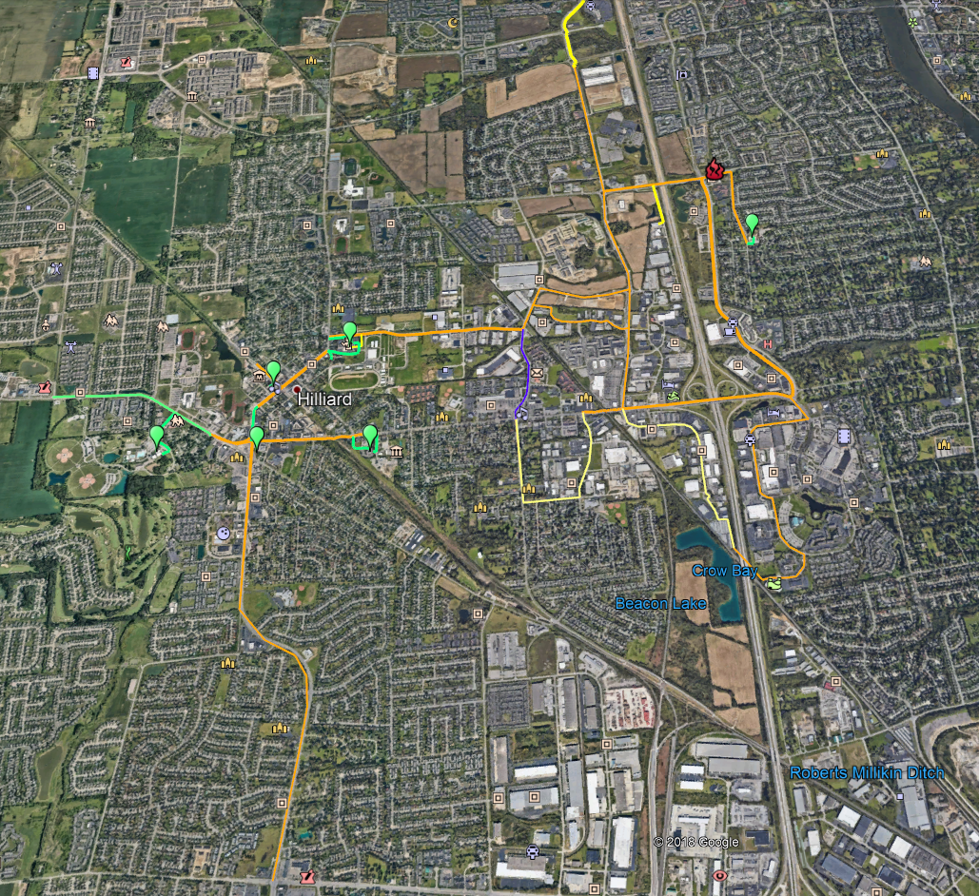

Exibit 3 Exsisting Duct bank (Please view attached PDF file for further details):

Inventory of existing City owned conduit to include all pull boxes, fiber cabinets, occupancy (if applicable) and verification conduit is clear of debris or obstruction. Please review the city-owned conduit assets in Exhibit 2 attached PDF for reference.

Exibit 4 Cememtery Rd Lacon Rd Existing Fiber (Please view attached PDF file for further details):

Interconnect with pre-exsiting aerial fiber on Cemetery Rd design options will be included in vendors response to include by not limited to meet me point, fusion vs patch, and location GPS interconnect. Further detail on existing fiber provided in Exhibit 4 PDF attachment.

Section 2C: Alternate Vendor Proposals

Public Private Partnership
The City may seek private investment or the lease of the fiber optic infrastructure to leverage available resources. The City seeks to serve the maximum number of commercial sites possible. The City seeks to serve municipal, school, township and other public locations in order to lower the long term cost of maintenance and operations of the network, and establish the framework to expand the network to addition communities and sites as resources become available.

Vendors having the business case and investment opportunity are encouraged to provide alternative proposals to the City of Hilliard including the use of alternative right of way paths and the use of existing conduit. Any alternate proposal must address fully, the services, needs and intent of the primary Engineering Fiber Network RFP; providing bandwidth services and development opportunities to the City through the use of broadband infrastructure.

The alternative proposal must outline the value proposition presented by the respondent with the equipment, services and operational components identified and explained in detail appropriate for City to evaluate the benefit to the region, benefit to the proposer and, any risk assessment considerations from entry into a contract based on the alternative proposal.

With the stated goal of the City to extend fiber based broadband connectivity to anchor institution, both public and private, across the entire City, alternate proposals that provide revenue sharing or financial resources that can be reinvested in systems expansion, direct investment in network fiber expansion, or other partnership or relationship that will enhance the sustainability of the City Fiber Network are of great interest.

Section 3: Project Pricing
Please provide a total cost for all design, engineering, and documentation requirements included in this RFP as stated in the Scope of Work.

3.1 Cost by Segment for Proposed Primary Fiber Optic Network Routes

From | To | Distance in Feet | Cost

3.2 Cost by Segment for Proposed Secondary Fiber Optic Network Routes
Location | Entity | Distance | Cost

4.0 Required Contract Terms

4.1. These are the required contract terms that a Successful Proposer shall agree to by submitting the Proposal for consideration. Any contract with the City of Hilliard shall include these provisions.

4.1.1 Applicable laws:
The Revised Code of the State of Ohio, the Charter of the City of Hilliard and all City ordinances and administrative rules insofar as they apply to the laws of competitive bidding, contracts and purchases are made a part hereof. Legal action to enforce this agreement shall only be brought in a court of competent jurisdiction in Franklin County, Ohio.

4.1.2 Indemnification by Proposer:
To the fullest extent allowed by law, the Proposer shall indemnify and hold harmless the City, its employees and agents, from any liability for claims, damages, losses and expenses, including reasonable attorney fees, resulting from the negligent performance of the contract, or any negligent act or omission, by Proposer, its employees, agents, subcontractors or assigns. Proposer’s obligation to indemnify under this section shall not be construed to negate, abridge, or reduce other rights of indemnity or contribution to which the City, its agents or employees are legally entitled.

4.1.3 No indemnification by City:
The City does not agree to indemnify or hold harmless the Proposer, its employees and agents, from any liability for claims, damages, losses and expenses, including reasonable attorney fees, resulting from or arising under the contract.

4.1.4 Insurance:
The Proposer shall not commence work under this contract until he/she has obtained all insurance required under this paragraph and such insurance has been approved by the City nor shall the Proposer allow any subcontractors to commence work on this subcontract until all similar insurance required for coverage of the subcontractor has been so obtained and approved.

The Proposer shall take out and maintain during the life of this contract, Workers’ Compensation Insurance for all of his/her employees employed on the project, and in case any work is sublet, the Proposer shall require the subcontractor similarly to provide Workers’ Compensation Insurance for all of the latter’s employees unless such employees are covered by the protection afforded by the Proposer. If the Proposer already maintains Worker’s Compensation Insurance, Proposer shall submit proof of such coverage to the City with Proposer’s submission and thereafter upon request. Proposer shall maintain such insurance throughout the life of any contract with the City.

4.1.5 Municipal income tax:
The Proposer shall withhold all City income taxes due or payable under the provisions of the Income Tax ordinance for wages, salaries, and commissions paid to its employees pursuant to Chapter 183 of the Ordinances of the City of Hilliard , Ohio. The Proposer shall require its subcontractors to withhold any such City income taxes due for services performed under this Contract. The Proposer will be required to sign a tax affidavit as required under section 5719.042 of the Ohio Revised Code.

4.1.6 Force majeure:
For the purpose hereof, force majeure shall be any of the following events: acts of God or the public enemy; compliance with any order, rule, regulation, decree, or request of any governmental authority or agency or person purporting to act therefore; acts of war, public disorder, rebellion, terrorism, or sabotage; floods, hurricanes, or other storms; strikes or labor disputes; or any storms; strikes or labor disputes; or any other cause, whether or not of the class or kind specifically named or referred to herein not within the reasonable control of the party affected. A delay in or failure of performance of either party shall not constitute a default hereunder nor be the basis for, or give rise to, any claim for damages, if and to the extent such delay or failure is caused by force majeure. The party who is prevented from performing by force majeure (i) shall be obligated, within a period not to exceed fourteen (14) days after the occurrence or detection of any such event, to give notice to other party setting forth in reasonable detail the nature thereof and the anticipated extent of the delay, and (ii) shall remedy such cause as soon as reasonably possible.

4.1.7 Termination of contract for cause:
If, through any cause, the Proposer shall fail to fulfill in a timely manner and proper manner its obligations or if the Proposer shall violate any of the covenants, agreements or stipulations of the contract, the City shall thereupon have the right to terminate the contract by giving written notice to the Proposer of such termination and specifying the effective date of termination. The notice may be mailed, hand-delivered, or sent electronically. In that event, and as of the time notice is given by the City, all finished or unfinished services, reports or other materials prepared by the Proposer shall, at the option of the City, become its property, and the Proposer shall be entitled to receive compensation for any satisfactory work completed, prepared documents or materials as furnished. Notwithstanding the above, the Proposer shall not be relieved of liability to the City for damage sustained by the City by virtue of breach of the contract by the Proposer and the City may withhold any payments to the Proposer for the purpose of set off until such time as the exact amount of damages due the City from the Provider is determined.

4.1.8 Termination of contract for convenience:
The City may terminate the contract at any time by giving written notice to the Proposer of such termination and specifying the effective date thereof, at least thirty (30) working days before the effective date of such termination. The notice may be mailed, hand-delivered, or sent electronically. In that event, all finished or unfinished services, reports, material(s) prepared or furnished by the successful Proposer under the contract shall, at the option of the City, become its property. If the contract is terminated due to the fault of the successful Proposer, termination of contract for cause relative to termination shall apply. If the contract is terminated by the City as provided herein, the successful Supplier will be paid an amount as of the time notice is given by the City which bears the same ratio to the total compensation as the services actually performed or material furnished bear to the total services/materials the successful Proposer covered by the contract, less payments of compensation previously made.

4.1.9 Proposal and contract information is public:
The Proposer acknowledges that all documents submitted with any proposal may become public documents and shall be subject to Ohio Revised Code Section 149.43, which is otherwise known as the Ohio Public Records Law”. By submitting any document to the City of Hilliard in connection with a Proposal or Contract, the Proposer waives any claim against the City of Hilliard and any of its officers and employees relating to the release of any document or information submitted. Furthermore, the Proposer agrees to hold the City of Hilliard and its officers and employees harmless from any claims arising from the release of any document or information made available to the City of Hilliard arising from or related to the Proposal or Contract.

4.2 The terms and conditions of the RFP shall be incorporated and made part of the contract between the City and the successful Proposer. In case of any conflict between the term and conditions of the RFP and the Proposal, the RFP shall prevail unless otherwise agreed upon in writing by the City. The City reserves the right to incorporate terms and conditions contained in the Proposal provided it is not in conflict with the RFP.

4.3 The Proposal should include any proposed contractual terms that the Proposer intends to request the City to include in the contract. Such terms and conditions should not conflict with the required contract terms in this Section. If the proposed contractual terms conflict with the required contract terms, the City may reject the Proposal. The City reserves the right, but not the obligation, to negotiate additional terms with the Successful Proposer. The Proposer shall provide on the front page of the proposal and titled as “Conflict with Required Contract Terms” all terms and conditions of the Proposal that conflict with the required contract terms.

4.4 Acknowledgement:
The undersigned hereby acknowledges that:
The undersigned has read and understands the terms and conditions of the RFP, including the required contract terms.
The undersigned has the lawful authority to sign this document on behalf of the Proposer.
If the Proposal is selected, the undersigned’s signature incorporates the required contract terms into the final contract and shall supersede any subsequent contract terms provided by the Proposer, unless otherwise agreed to by the City pursuant to Section 4.3.

Signature: __________________________________

Print Name: __________________________________ Date: __________________________________

THIS PAGE IS MANDATORY.

 | YES | NO
Does your company have a formal safety policy and your employees participate in safety training?
Upon request, would you be able to provide the City with a copy of your safety policy?

REFERENCES

AUTHORIZED NEGOTIATORS:

Name:
Title:
Phone #:

Name:
Title:
Phone #:

THIS PAGE IS MANDATORY.

List three (3) references that you have done similar work, service or supplied similar products to within the last twelve (12) months (Only correct contact names and phone numbers will be acceptable).

Entity:
Address:
City, State, Zip Code:
Telephone Number:
Contact Person:
Title:
Email:

Entity:
Address:
City, State, Zip Code:
Telephone Number:
Contact Person:
Title:
Email:

Entity:
Address:
City, State, Zip Code:
Telephone Number:
Contact Person:
Title:
Email:

*State full names, titles and addresses of all responsible principles and/or partners below;

Name: |  | Title:
Address

Name: |  | Title:
Address

Name: |  | Title:
Address

Name: |  | Title:
Address

PROPOSER'S CERTIFICATION
I have carefully examined the Request for Proposal, Requirements for Statements of Qualifications, Scope of Services Background, and any other documents accompanying or made a part of this Request for Proposal.
I hereby propose to furnish the goods or services specified in the Request for Proposal. I agree that my proposal will remain firm for a period of up to one hundred twenty (120) days in order to allow the City adequate time to evaluate the qualifications submitted.
I verify that all information contained in this proposal is truthful to the best of my knowledge and belief. I further certify that I am duly authorized to submit this proposal on behalf of the firm as its act and deed and that the firm is ready, willing and able to perform if awarded the contract.
I further certify, under oath, that this proposal is made without prior understanding, agreement, connection, discussion, or collusion with any other person, firm or corporation submitting a proposal for the same product or service. No officer, employee or agent of the City of Hilliard or any other proposer is interested in said proposal and that the undersigned executed this Proposer's Certification with full knowledge and understanding of the matters therein contained and was duly authorized to do so.
*State of Incorporation
(Individual - Partnership - Company - Corporation)
(Business Address)

(City, State, and Zip Code)

(By Signature) |  | (Title)
(Witness Signature) |  | (Title)
(Telephone No.) |  | (Date)

