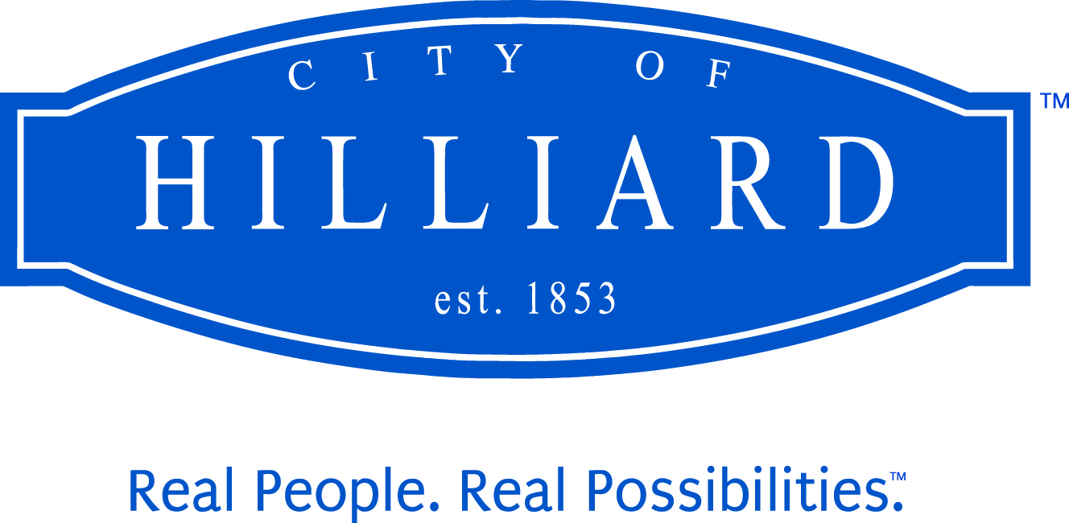 | City  Council

2020 Regular Meeting Dates
Second and Fourth Monday of the Month
All meetings begin at 7:00 p.m., unless otherwise noted

January 6 Organizational Meeting and Regular Meeting
January 27

February 10
February 24

March 09
March 23

April 13
April 27

May 11
May 25 - Memorial Day Holiday – City Hall closed, no meeting
May 26*

June 08
June 22

July 13

Summer Recess

August 24

September 14
September 28

October 12 - Columbus Day Holiday - City Hall closed, no meeting
October 13*
October 26

November 9
November 23

December 14
December 28

*Tuesday meetings due to Monday holidays

hilliardohio.gov

