

City of Hillard Community Center Study  
 April 8, 2021

Table of Contents

Section I – Executive Summary ………………………………….2

Section II – Market Analysis.……………………………………. 7

Section III – Participation and Trends ……….………………… 31

Section IV – Alternative Service Provider.…..…………………..47

Section V – Recreation Programs and Services …………………50

Section VI – Stakeholder Meetings …….…………………….….54

Section VII – Program Recommendation …………………….….58

Section VIII – Operation Analysis………………………………..61

Section XI – Appendix ………………………………………..….67

# Section I Executive Summary

**Background:**

Ballard*King and Associates (B*K), along with ETC Leisure Vision (ETC) were hired to conduct a market analysis and feasibility study for a Community Center in Hilliard. The objective of this study was to determine the overall need for a Community Center and the feasibility of the project. Project tasks included a demographic assessment of the regional area, numerous stakeholder meeting, community-wide survey, review of existing recreation providers in the area, exploring potential partnerships, program recommendations, and operating pro-forma.

**Market Analysis:**

The City of Hilliard’s population (service area) is increasing at robust rate of 9.4% with the population projected to reach 41,729 people by the year 2025. The demographic profile of the community indicates an aging population. The age group distribution is somewhat mixed in this service area. There is a higher concentration of the 0-5, 5-17, 25-44, 45-54 and 55-64 age categories than the national level and lower concentration of in the 18-24, 65-74 and over 75 age categories than the national level. The median age of the primary service area is lower (1.2 years) than the than the national level of 38.5 years. Approximately 44.4% of households in the service area are households with children compared to a national level of 33.4%. The median household income is significantly higher (56.7%) than the national level of $62,203. The number of households with income of $50,000 or higher is 79% compared to a national level of 60%. A factor that must be considered is that the housing/dwelling expense in the service area is 32% higher than the national level. This suggests that the ratio between household income and housing expenses is above average. Age and household income are two determining factors that drive participation in sports, recreation and wellness activities. When factoring median age, household income and age distribution, the demographic profile suggests that the market conditions are favorable for supporting a community center.

Statistics from the National Sporting Goods Association (NSGA) were overlaid on to the demographic profile of the service areas to determine the market potential for various activities that could take place in an indoor facility. The market potential was measured against the existing inventory of recreation providers in the area and concluded that there is a shortage of swimming pools, gymnasium space and multi-purpose space, fitness space and classroom space in the service area. Additionally, there is a need to expand senior citizen space to the proposed community center as the existing center continues to age and does not meet the program needs.

**Stakeholder Meetings:**

A series of stakeholder meetings were conducted to gather input from potential user groups and partners regarding the Community Center. A wide variety of needs were expressed during these stakeholder meetings. Without question, an aquatic center was one of the most frequently heard components along with meeting room space, gymnasium, walking track, fitness, and dedicated art room which all received strong support. A total of 34 different agencies and organizations participated in the stakeholder meetings including the following:

Senior Center YMCA

Churches Nemeth Counseling

Ohio State Syntero

Hilliard Arts Council Mount Carmel

City Parks and Recreation Staff Colts

Hilliard Baseball HGSA

NW Soccer Club Hilliard Assistance Council

Optimist Sports St Brendan’s

Girls Softball Equity

Marlin’s Swim Team Credit Union of Ohio

HOSA Soccer Coffee Connections

Chamber of Commerce Advanced Drainage Systems

Food Pantry Dogwatch

Kiwanis Club Hilliard Graeter’s

Security Plus Insurance Crooked Can

Hilliard City SD Brown Township

Norwich Township Darby Athletics

**Programming:**

The program recommendations for the Community Center were driven by the information gathered during the market analysis, including the demographic profile of the community, statistical data from the National Sporting Goods Association, stakeholder input, competitive analysis of other recreation and sport facilities in the area, and community-wide survey. During the program phase of the study, different options were explored before developing a final recommendation. Based on the market analysis, program assessment and budgetary considerations the following program summary is possible for the Community Center.

|  |  |
| --- | --- |
| Component | Sq. Ft. Size |
| Gymnasium | 18,000 |
| Auxiliary Gym | 5,000 |
| Fitness Space | 6,000 |
| Group Exercise | 2,000 |
| Dedicated Senior Center | 4,000 |
| Classrooms | 1,200 |
| Multi-Purpose Room | 3,500 |
| Indoor Playground | 3,000 |
| Child Watch | 2,500 |
| Aquatic Center | 18,000 |
| Community Gathering Space | 6,000 |
| Resource Center | 300 |
| Art Room | 3,000 |
| Maker Space | 1,000 |
| Support Spaces | 12,500 |
| Sub-Total | 85,500 |
| Circulation (18%) | 15,000 |
| Total | 100,500 |

**Operations:**

An operation analysis was conducted to examine operational costs and revenues for the Community Center. The operating pro-forma developed represents a conservative approach to estimating expenses and revenues and was completed based on the best information available and a basic understanding of the current area operations.

The results of the operations analysis indicate that the proposed expansion of the Center will not recover 100% of its operating costs through revenue. The operating pro-forma does not include debt service since the funding for this project is yet to be determined. A center with a multi-court gymnasium, warm water leisure pool with zero depth entry and play features, lap pool, multi-purpose room, walking/jogging track, fitness center with cardiovascular and weightlifting area, group exercise rooms, birthday party rooms, child watch area, dedicated senior space, community gather space, resources center, indoor play structure, maker space, dedicated classroom space, support offices, administration area and lobby. The center is approximately 100,500 SF.

Expense – Revenue Comparison

|  |  |
| --- | --- |
| **Category** | **Facility Budget** |
| Expense | $ 2,526,977 |
| Revenue | $ 2,005,175 |
| Difference | $ (521,802) |
| Cost Recovery | 79% |

**Conclusion:**

The market conditions suggest support for the Community Center. The proposed facility, by virtue of the leisure pool, competition pool, multiple gymnasium space, fitness, indoor walking/jogging track, dedicated senior space, indoor play structure, birthday party rooms, dedicated art room, dedicated senior citizen space and community gathering spaces differentiate this facility from any other facility in the region. The Community Center is ideally positioned to not only improve the quality of the facilities in the area, but also to enhance the quality of life for residents while becoming an identifying landmark to the Hilliard.

Weekly participation in active recreation activities from area residents can be expected to be somewhere in the range of 10%-12% of the population which equals approximately 3,815-4,578 individuals, (based on 2020 population estimates for service area). This is a sufficient population base to rely on for the operation of a full-scale center. The success of similar facilities in other areas of the country suggests that these types of centers have been cost effective in meeting local sport and wellness needs.

Without question, a new Community Center will enhance the quality of life in the area while improving recreation and wellness opportunities. The proposed center fills the service gaps for a variety of recreation, swimming and expands the wellness access in the community for children, teenagers, families and seniors. A new facility will become a source of tremendous community pride and will bring the community together along with making the Hilliard more attractive for employers and employees alike. The center will also help establish and recognize the facility as a contributor to the economic health of the community by providing jobs, through the purchase of local goods and services and by generating tourism trade for the Hilliard area.

# Section II – Market Assessment

Ballard*King & Associates (B*K) has contracted with the City of Hilliard to complete a market assessment for a community center. The first step to complete this scope of work is to determine service areas for analysis and recreation/leisure activities.

The following is a summary of the demographic characteristics within areas identified as Primary and Secondary Service Areas. The Primary Service Area is the boundaries of the city limits of Hilliard and the Secondary Service Area is the Hilliard School District.

B*K accesses demographic information from Environmental Systems Research Institute (ESRI) who utilizes 2010 Census data and their demographers for 2020-2025 projections. In addition to demographics, ESRI also provides data on housings, recreation, and entertainment spending and adult participation in activities. B*K also uses information produced by the National Sporting Goods Association (NSGA) to overlay onto the demographic profile to determine potential participation in various activities.

**Service Areas:**

The information provided includes the basic demographics and data for the Primary and Secondary Service Area with comparison data for the State of Ohio and the United States.

The Primary Service Areas are defined as the distance people will travel on a regular basis (a minimum of once a week) to utilize recreation facilities. Use by individuals outside of this area will be much more limited and will focus more on special activities or events.

Service areas can flex, or contract based upon a facility’s proximity to major thoroughfares. Other factors impacting the use as it relates to driving distance are the presence of alternative service providers in the service area. Alternative service providers can influence participation, membership, daily admissions and the associated penetration rates for programs and services.

Service areas can vary in size with the types of components in the facility.

**Map A – Service Area Maps**

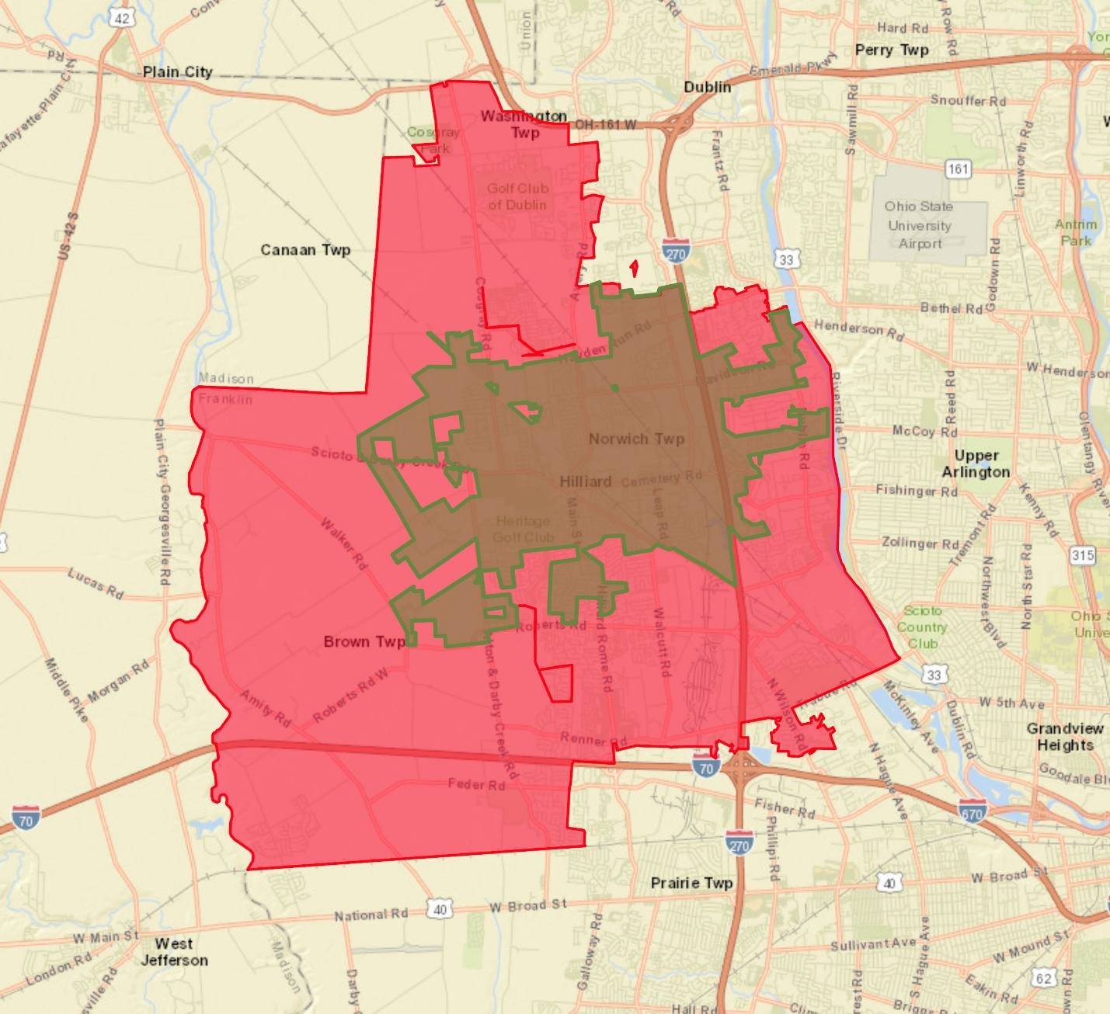

* Primary Service Area – Green Boundary – City of Hilliard
* Secondary Service Area – Red Boundary – Hilliard School District

**Infographic**

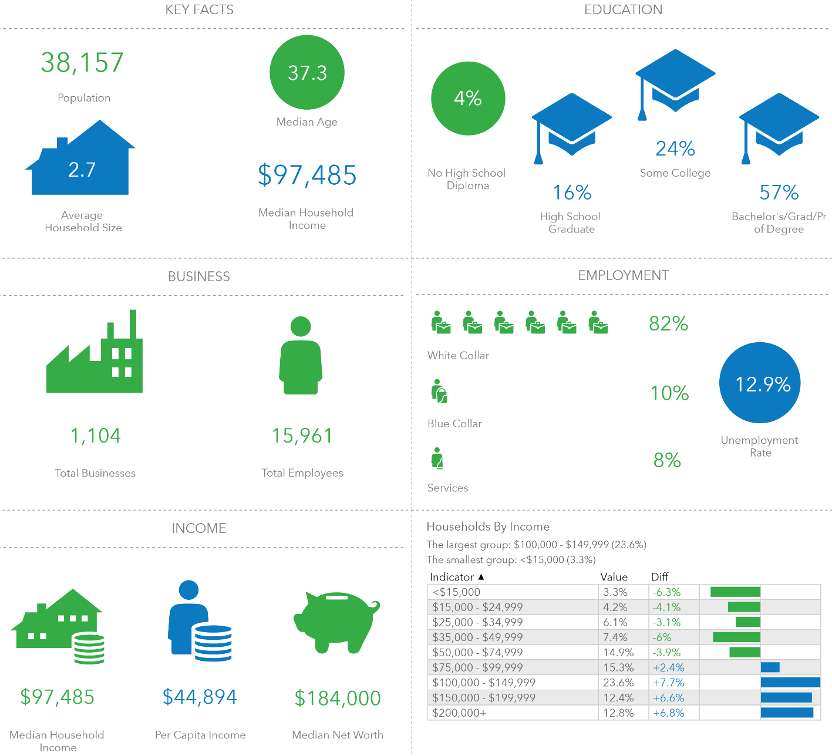

* Household by Income comparison uses the Primary Service Area and compares it to Franklin County.

# Demographic Summary

|  |  |  |
| --- | --- | --- |
|  | **Primary**  **Service Area** | **Secondary**  **Service Area** |
| **Population:** |  |  |
| 2010 Census | 28,407[1] | 86,988[2] |
| 2020 Estimate | 38,157 | 105,575 |
| 2025 Estimate | 41,729 | 113,921 |
| **Households:** |  |  |
| 2010 Census | 10,188 | 33,354 |
| 2020 Estimate | 13,863 | 40,573 |
| 2025 Estimate | 15,184 | 43,785 |
| **Families:** |  |  |
| 2010 Census | 7,608 | 22,593 |
| 2020 Estimate | 9,931 | 26,932 |
| 2025 Estimate | 10,846 | 28,911 |
| **Average Household Size:** |  |  |
| 2010 Census | 2.77 | 2.60 |
| 2020 Estimate | 2.74 | 2.60 |
| 2025 Estimate | 2.74 | 2.60 |
| **Ethnicity**  **(2020 Estimate):** |  |  |
| Hispanic | 3.6% | 5.3% |
| White | 81.5% | 78.0% |
| Black | 3.9% | 5.5% |
| American Indian | 0.2% | 0.2% |
| Asian | 10.6% | 10.8% |
| Pacific Islander | 0.0% | 0.0% |
| Other | 1.1% | 2.4% |
| Multiple | 2.7% | 3.1% |
| **Median Age:** |  |  |
| 2010 Census | 35.9 | 33.4 |
| 2020 Estimate | 37.3 | 35.9 |
| 2025 Estimate | 37.8 | 36.0 |
| **Median Income:** |  |  |
| 2020 Estimate | $97,485 | $89,664 |
| 2025 Estimate | $103,051 | $96,791 |

**Age and Income:** The median age and household income levels are compared with the national number as both of these factors are secondary determiners of participation in recreation activities. The lower the median age, the higher the participation rates are for most activities. The level of participation also increases as the median income level goes up.

**Table A – Median Age:**

|  |  |  |  |
| --- | --- | --- | --- |
|  | **2010 Census** | **2020 Projection** | **2025 Projection** |
| Primary Service Area | 35.9 | 37.3 | 37.8 |
| Secondary Service Area | 33.4 | 35.9 | 36.0 |
| State of Ohio | 38.7 | 40.2 | 41.0 |
| Nationally | 37.1 | 38.5 | 39.3 |

**Chart A – Median Age:**

The median age in the Service Areas are slightly lower than the State of Ohio and the National number. A lower median age typically points to the presence of families with children. Recreation Centers draw a large demographic but tend to be most popular with families. Grandparents are becoming an increasing part of the household though as they care for and are involved with their grandchildren.

The following chart provides the number of households and percentage of households in the Primary and Secondary Service Area with children.

**Table B – Households w/ Children**

|  |  |  |
| --- | --- | --- |
|  | **Number of Households w/ Children** | **Percentage of Households w/ Children** |
| Primary Service Area | 4,525 | 44.4% |
| Secondary Service Area | 12,926 | 38.8% |
| State of Ohio | -- | 31.3% |

The information contained in Table-B helps further outline the presence of families with children. As a point of comparison in the 2010 Census, 33.4% of households nationally had children present.

**Map B – Median Age by Census Tract**

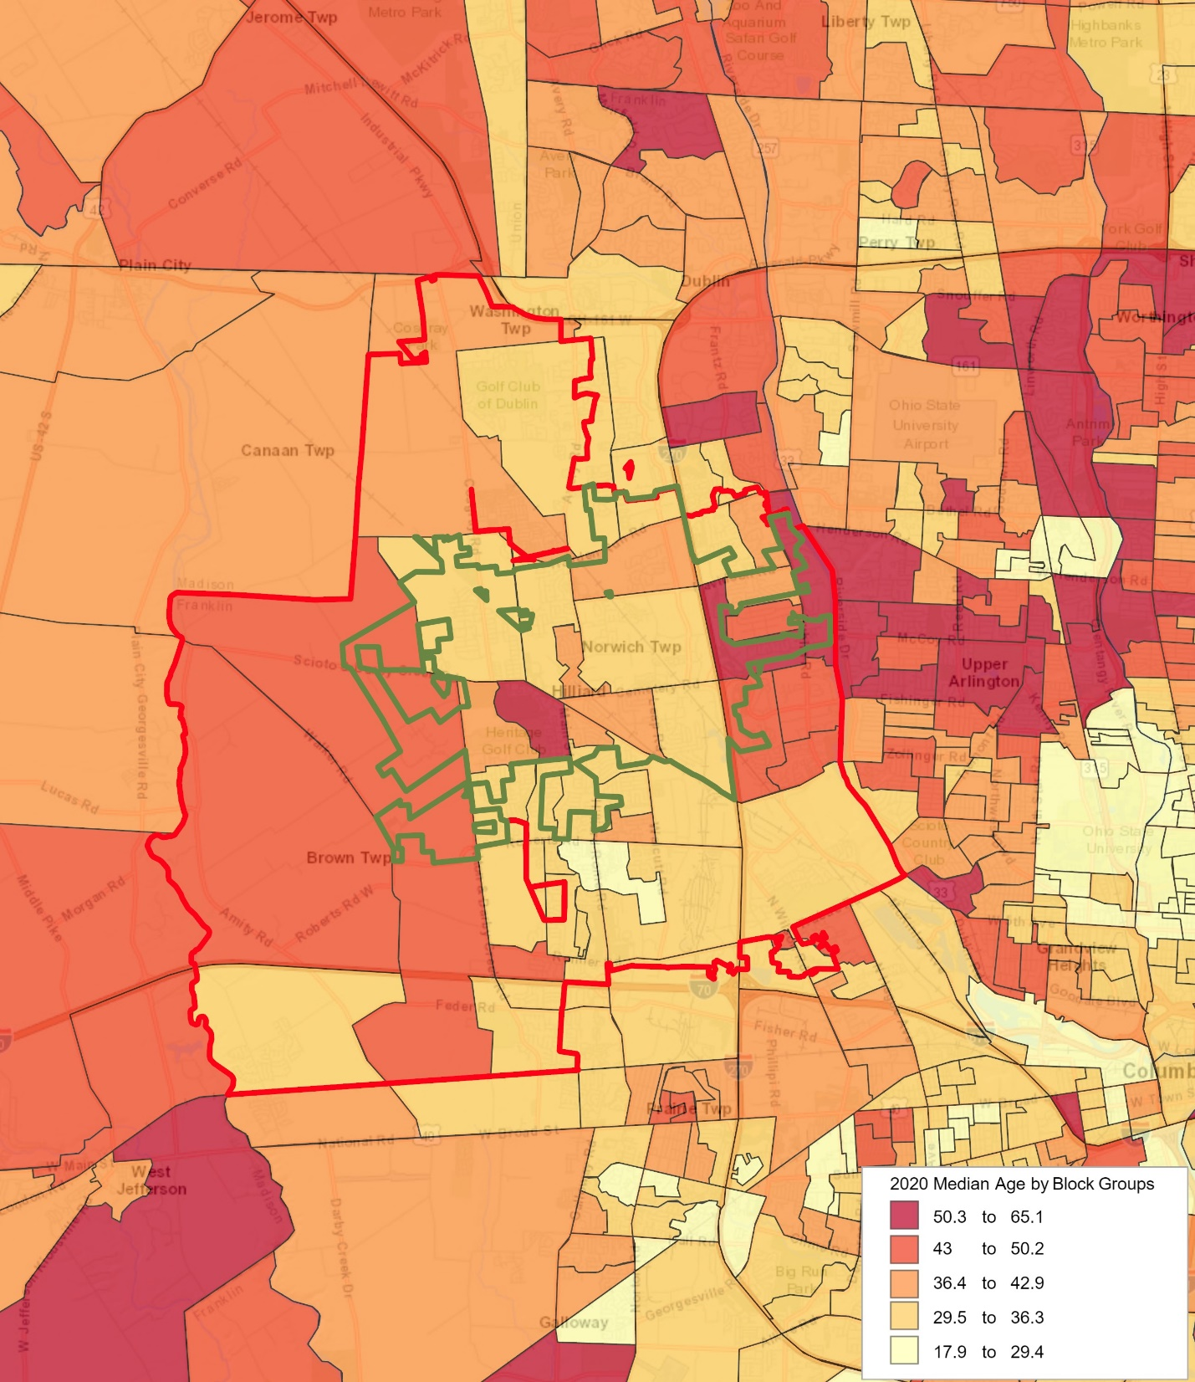

**Table C – Median Household Income:**

|  |  |  |
| --- | --- | --- |
|  | **2020 Projection** | **2025 Projection** |
| Primary Service Area | $97,485 | $103,051 |
| Secondary Service Area | $89,664 | $96,791 |
| State of Ohio | $56,352 | $60,126 |
| Nationally | $62,203 | $67,325 |

**Chart B – Median Household Income:**

Based on 2020 projections for median household income the following narrative describes the service areas:

In the Primary Service Area, the percentage of households with median income over $50,000 per year is 79.0% compared to 59.0% on a national level. Furthermore, the percentage of the households in the service area with median income less than $25,000 per year is 7.5% compared to a level of 14.3% nationally.

In the Secondary Service Area, the percentage of households with median income over $50,000 per year is 77.1% compared to 59.0% on a national level. Furthermore, the percentage of the households in the service area with median income less than $25,000 per year is 7.7% compared to a level of 14.3% nationally.

While there is no perfect indicator of use of an aquatic facility, the percentage of households with more than $50,000 median income is a key indicator. Therefore, those numbers are significant and balanced with the overall cost of living.

**Chart C – Median Household Income Distribution**

**Map C – Household Income by Census Tract**

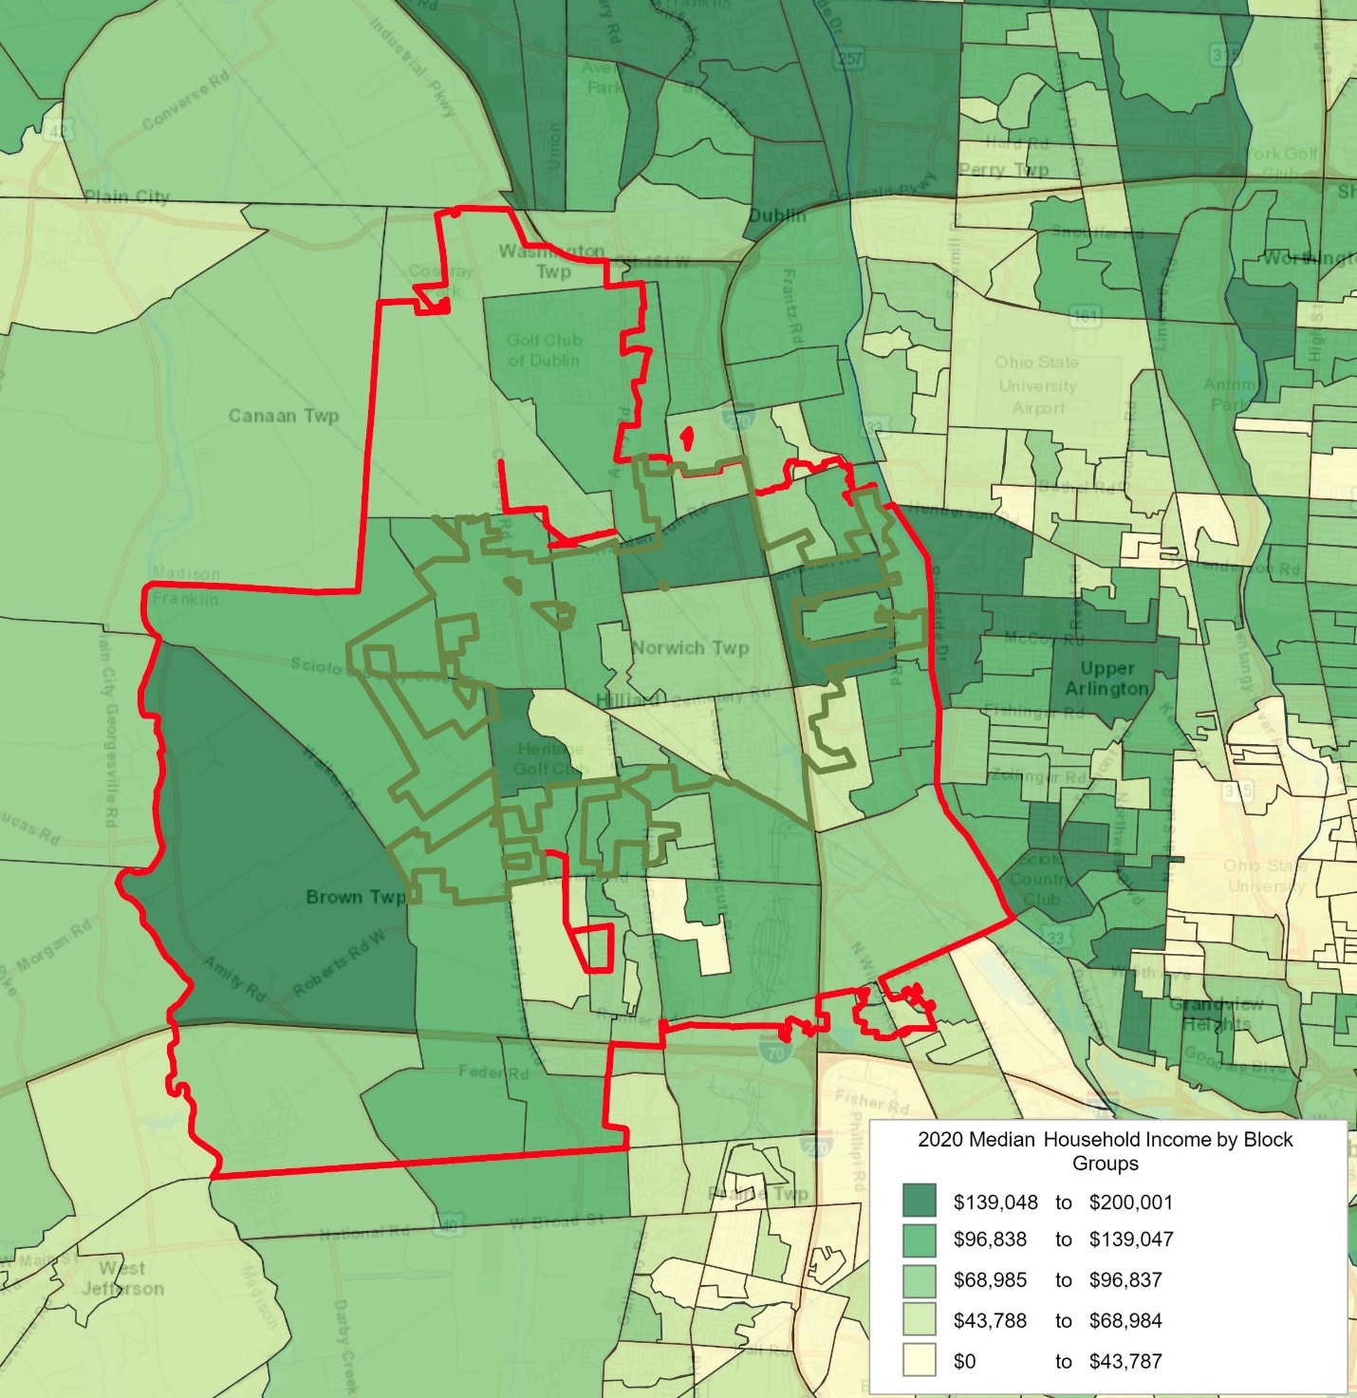

In addition to exploring the Median Age and Median Income, it is important to examine Household Budget Expenditures. In particular, reviewing housing information; shelter, utilities, fuel and public services along with entertainment & recreation can provide a snapshot into the cost of living and spending patterns in the services areas. The table below looks at that information and compares the service areas.

**Table D – Household Budget Expenditures[3]:**

|  |  |  |  |
| --- | --- | --- | --- |
| **Primary Service Area** | **SPI** | **Average Amount Spent** | **Percent** |
| Housing | 132 | $32,006.29 | 31.2% |
| *Shelter* | *133* | *$25,715.45* | *25.1%* |
| *Utilities, Fuel, Public Service* | *129* | *$6,290.84* | *6.1%* |
| Entertainment & Recreation | 132 | $4,297.95 | 4.2% |

|  |  |  |  |
| --- | --- | --- | --- |
| **Secondary Service Area** | **SPI** | **Average Amount Spent** | **Percent** |
| Housing | 119 | $28,950.10 | 31.3% |
| *Shelter* | *120* | *$23,246.06* | *25.1%* |
| *Utilities, Fuel, Public Service* | *117* | *$5,704.03* | *6.2%* |
| Entertainment & Recreation | 119 | $3,860.93 | 4.2% |

|  |  |  |  |
| --- | --- | --- | --- |
| **State of Ohio** | **SPI** | **Average Amount Spent** | **Percent** |
| Housing | 85 | $20,735.04 | 30.9% |
| *Shelter* | *84* | *$16,309.46* | *24.3%* |
| *Utilities, Fuel, Public Service* | *91* | *$4,425.58* | *6.6%* |
| Entertainment & Recreation | 89 | $2,886.44 | 4.3% |

**SPI:** Spending Potential Index as compared to the National number of 100.

**Average Amount Spent:** The average amount spent per household.

**Percent:** Percent of the total 100% of household expenditures.

***Note:*** *Shelter along with Utilities, Fuel, Public Service are a portion of the Housing percentage.*

**Chart D – Household Budget Expenditures Spending Potential Index:**

The consistency between the median household income and the household budget expenditures is important. It also points to the fact that compared to a National level the disposable income is greater in Hillard than the national level. Household budget spending is 32% higher than the national level while the household income level id 56% higher than the national level. This could point to a greater capacity to pay for programs and services offered at a recreation facility of any variety.

The total number of housing units in the Primary Service Area is 10,618 and 96.0% are occupied, or 10,188 housing units. The total vacancy rate for the service area is 4.0%. Of the available units:

* For Rent 1.5%
* Rented, not Occupied 0.1%
* For Sale 1.3%
* Sold, not Occupied 0.2%
* For Seasonal Use 0.3%
* Other Vacant 0.7%

The total number of housing units in the Secondary Service Area is 35,162 and 94.9% are occupied, or 33,354 housing units. The total vacancy rate for the service area is 5.1%. Of the available units:

* For Rent 2.2%
* Rented, not Occupied 0.2%
* For Sale 1.4%
* Sold, not Occupied 0.2%
* For Seasonal Use 0.4%
* Other Vacant 0.7%

**Recreation Expenditures Spending Potential Index:** Finally, through the demographic provider that B*K utilizes for the market analysis portion of the report, we can examine the overall propensity for households to spend dollars on recreation activities. The following comparisons are possible.

**Table E – Recreation Expenditures Spending Potential Index[4]:**

|  |  |  |
| --- | --- | --- |
| **Primary Service Area** | **SPI** | **Average Spent per Person** |
| Fees for Participant Sports | 148 | $145.65 |
| Fees for Recreational Lessons | 144 | $208.74 |
| Social, Recreation, Club Membership | 139 | $331.91 |
| Exercise Equipment/Game Tables | 140 | $91.79 |
| Other Sports Equipment | 154 | $10.93 |

|  |  |  |
| --- | --- | --- |
| **Secondary Service Area** | **SPI** | **Average Spent per Person** |
| Fees for Participant Sports | 133 | $130.75 |
| Fees for Recreational Lessons | 128 | $185.79 |
| Social, Recreation, Club Membership | 123 | $294.22 |
| Exercise Equipment/Game Tables | 124 | $81.51 |
| Other Sports Equipment | 141 | $10.00 |

|  |  |  |
| --- | --- | --- |
| **State of Ohio** | **SPI** | **Average Spent per Person** |
| Fees for Participant Sports | 84 | $82.30 |
| Fees for Recreational Lessons | 78 | $112.41 |
| Social, Recreation, Club Membership | 83 | $199.82 |
| Exercise Equipment/Game Tables | 93 | $61.21 |
| Other Sports Equipment | 85 | $6.04 |

**Average Amount Spent:** The average amount spent per person for the service or item in a year.

**SPI:** Spending potential index as compared to the national number of 100.

**Chart E – Recreation Spending Potential Index:**

Again, there is a great deal on consistency between median household income, household budget expenditures and now recreation and spending potential.

**Map D – Recreation Spending Potential Index by Census Tract**

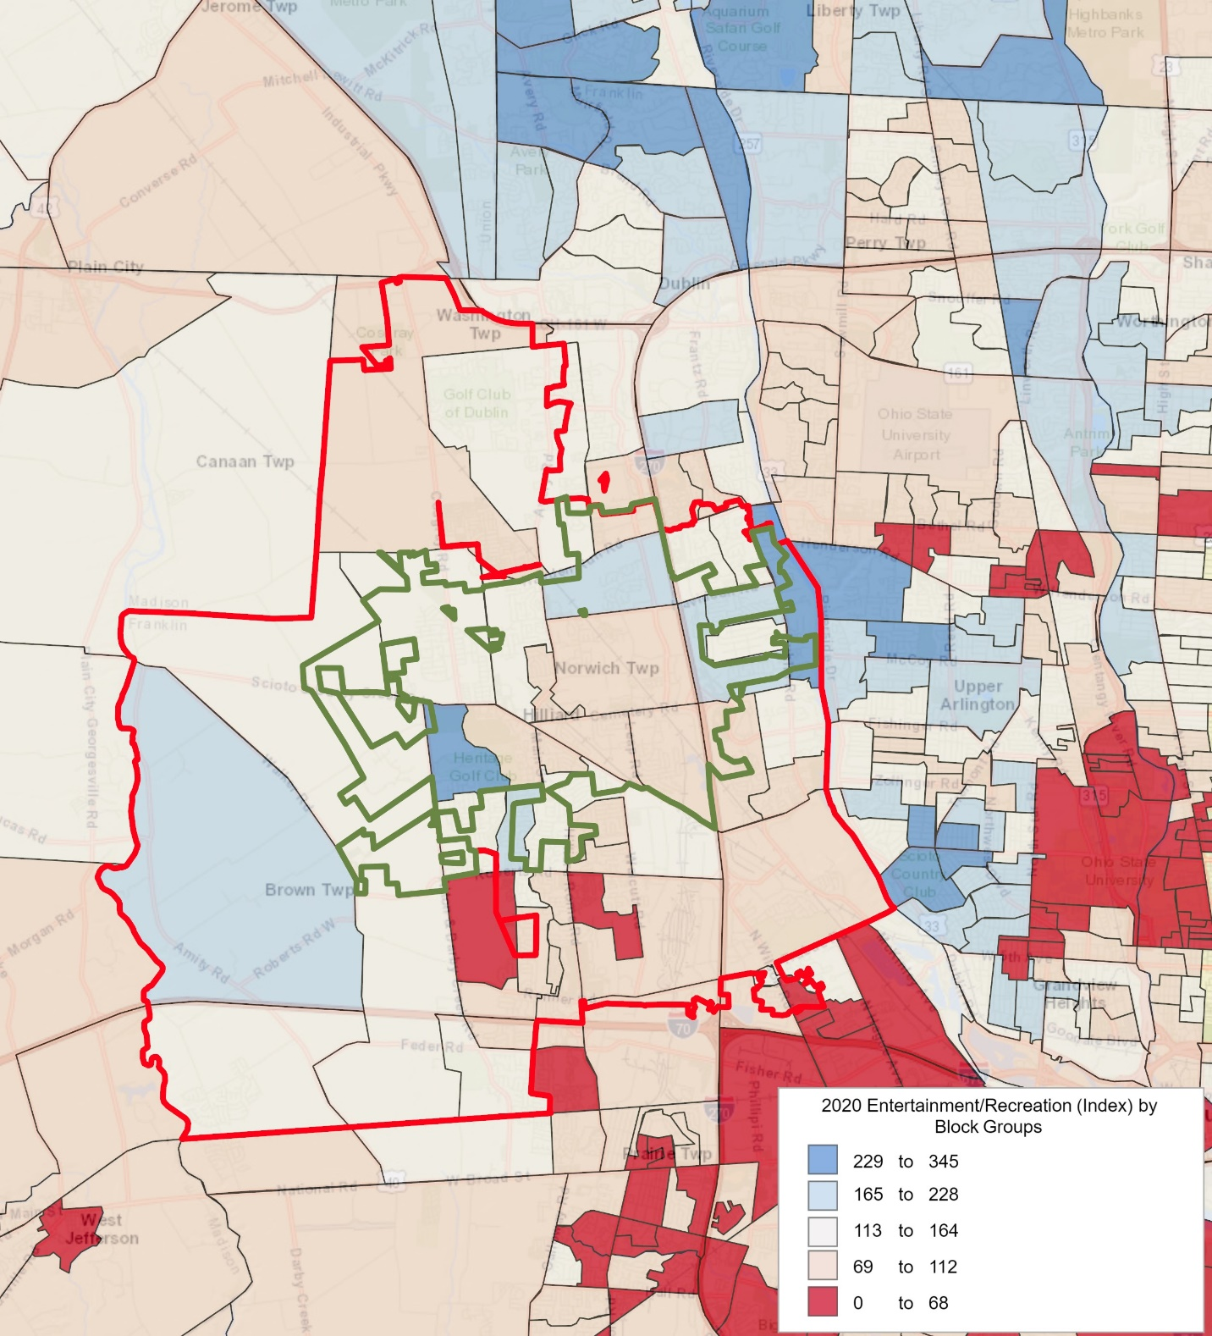

**Population Distribution by Age:** Utilizing census information for the Primary and Secondary Service Area, the following comparisons are possible.

**Table F – 2020 Primary Service Area Age Distribution**

(ESRI estimates)

|  |  |  |  |  |
| --- | --- | --- | --- | --- |
| **Ages** | **Population** | **% of Total** | **Nat. Population** | **Difference** |
| 0-5 | 2,412 | 6.4% | 6.0% | +0.4% |
| 5-17 | 6,903 | 18.2% | 16.0% | +2.2% |
| 18-24 | 3,129 | 8.2% | 9.4% | -1.2% |
| 25-44 | 10,959 | 28.7% | 26.6% | +2.1% |
| 45-54 | 5,170 | 13.5% | 12.4% | +1.1% |
| 55-64 | 4,998 | 13.1% | 13.0% | +0.1% |
| 65-74 | 2,829 | 7.4% | 9.8% | -2.4% |
| 75+ | 1,760 | 4.6% | 6.8% | -2.2% |

**Population:** 2020 census estimates in the different age groups in the Primary Service Area.

**% of Total:** Percentage of the Primary Service Area population in the age group.

**National Population:** Percentage of the national population in the age group.

**Difference:** Percentage difference between the Primary Service Area population and the national population.

**Chart F – 2020 Primary Service Area Age Group Distribution**

The demographic makeup of the Primary Service Area, when compared to the characteristics of the national population, indicates that there are some differences with a larger population in the under 6, 6-17, 25-44, 45-54, and 55-64age groups. A smaller population in the younger age groups 18-24, 65-74 and 75+. The greatest positive variance is in the 6-17 age group with +2.2%, while the greatest negative variance is in the 65-74 age group with -2.4%.

**Table G – 2020 Secondary Service Area Age Distribution**

(ESRI estimates)

|  |  |  |  |  |
| --- | --- | --- | --- | --- |
| **Ages** | **Population** | **% of Total** | **Nat. Population** | **Difference** |
| 0-5 | 7,341 | 7.0% | 6.0% | +1.0% |
| 5-17 | 19,223 | 18.2% | 16.0% | +2.2% |
| 18-24 | 8,730 | 8.3% | 9.4% | -1.1% |
| 25-44 | 33,047 | 31.2% | 26.6% | +4.6% |
| 45-54 | 13,941 | 13.2% | 12.4% | +0.8% |
| 55-64 | 12,388 | 11.7% | 13.0% | -1.3% |
| 65-74 | 7,088 | 6.7% | 9.8% | -3.1% |
| 75+ | 3,817 | 3.6% | 6.8% | -3.2% |

**Population:** 2020 census estimates in the different age groups in the Secondary Service Area.

**% of Total:** Percentage of the Secondary Service Area population in the age group.

**National Population:** Percentage of the national population in the age group.

**Difference:** Percentage difference between the Secondary Service Area population and the national population.

**Chart G – 2020 Secondary Service Area Age Group Distribution**

The demographic makeup of the Secondary Service Area, when compared to the characteristics of the national population, indicates that there are some differences with a larger population in the age groups Under 5, 6-17, 25-44, and 45-54, . A smaller population in the 18-24, 55-64, 65-74 and 75+ age groups. The greatest positive variance is in the 25-44 age group with +4.6%, while the greatest negative variance is in the 75+ age group with -3.2%.

**Population Distribution Comparison by Age:** Utilizing census information from the Primary and Secondary Service Area, the following comparisons are possible.

**Table H – 2020 Primary Service Area Population Estimates**

(U.S. Census Information and ESRI)

|  |  |  |  |  |  |
| --- | --- | --- | --- | --- | --- |
| **Ages** | **2010 Census** | **2020 Projection** | **2025 Projection** | **Percent Change** | **Percent Change Nat’l** |
| -5 | 1,982 | 2,412 | 2,616 | +32.0% | +2.1% |
| 5-17 | 6,565 | 6,903 | 7,124 | +8.5% | +0.7% |
| 18-24 | 1,803 | 3,129 | 3,086 | +71.2% | +0.5% |
| 25-44 | 8,130 | 10,959 | 12,330 | +51.7% | +13.0% |
| 45-54 | 4,813 | 5,170 | 5,290 | +9.9% | -9.9% |
| 55-64 | 2,657 | 4,998 | 5,106 | +92.2% | +15.4% |
| 65-74 | 1,272 | 2,829 | 3,785 | +197.6% | +69.8% |
| 75+ | 1,185 | 1,760 | 2,398 | +102.4% | +50.2% |

**Chart H – Primary Service Area Population Growth**

Table-I illustrates the growth or decline in age group numbers from the 2010 census until the year 2025. It is projected all age categories will see an increase in population. The population of the United States as a whole is aging, and it is not unusual to find negative growth numbers in the younger age groups and significant net gains in the 45 plus age groupings in communities which are relatively stable in their population numbers.

**Table I – 2020 Secondary Service Area Population Estimates**

(U.S. Census Information and ESRI)

|  |  |  |  |  |  |
| --- | --- | --- | --- | --- | --- |
| **Ages** | **2010 Census** | **2020 Projection** | **2025 Projection** | **Percent Change** | **Percent Change Nat’l** |
| -5 | 6,949 | 7,341 | 7,916 | +13.9% | +2.1% |
| 5-17 | 17,077 | 19,223 | 19,998 | +17.1% | +0.7% |
| 18-24 | 6,383 | 8,730 | 9,348 | +46.5% | +0.5% |
| 25-44 | 29,692 | 33,047 | 35,273 | +18.8% | +13.0% |
| 45-54 | 13,058 | 13,941 | 14,698 | +12.6% | -9.9% |
| 55-64 | 7,973 | 12,388 | 12,472 | +56.4% | +15.4% |
| 65-74 | 3,372 | 7,088 | 8,974 | +166.1% | +69.8% |
| 75+ | 2,484 | 3,817 | 5,239 | +110.9% | +50.2% |

**Chart I – Secondary Service Area Population Growth**

Table-I illustrates the growth or decline in age group numbers from the 2010 census until the year 2025. It is projected all age categories will see an increase in population. The population of the United States as a whole is aging, and it is not unusual to find negative growth numbers in the younger age groups and significant net gains in the 45 plus age groupings in communities which are relatively stable in their population numbers.

Below is listed the distribution of the population by race and ethnicity for the Primary and Secondary Service Area for 2020 population projections. The U.S. Census defines Hispanic as an ethnicity require federal agencies to use a minimum of two ethnicities in collecting and reporting data. The Government defines Hispanic or Latino as a person from Cuba, Mexico, Puerto Rico, South or Central America. and should not be confused as a race. Those numbers were developed from 2020 Census Data.

**Table J – Primary Service Area Ethnic Population and Median Age 2020**

(Source – U.S. Census Bureau and ESRI)

|  |  |  |  |  |
| --- | --- | --- | --- | --- |
| **Ethnicity** | **Total Population** | **Median Age** | **% of Population** | **% of OH Population** |
| Hispanic | 1,359 | 24.9 | 3.6% | 4.2% |

**Table K – Primary Service Area by Race and Median Age 2020**

(Source – U.S. Census Bureau and ESRI**)**

|  |  |  |  |  |
| --- | --- | --- | --- | --- |
| **Race** | **Total Population** | **Median Age** | **% of Population** | **% of OH Population** |
| White | 31,083 | 39.3 | 81.5% | 80.0% |
| Black | 1,474 | 29.3 | 3.9% | 12.9% |
| American Indian | 61 | 34.2 | 0.2% | 0.2% |
| Asian | 4,051 | 33.9 | 10.6% | 2.6% |
| Pacific Islander | 9 | 16.3 | 0.0% | 0.0% |
| Other | 436 | 24.6 | 1.1% | 1.5% |
| Multiple | 1,046 | 16.6 | 2.7% | 2.7% |

2020 Primary Service Area Total Population: 38,157 Residents

**Chart J – 2020 Primary Service Area Population by Non-White Race**

**Table L – Secondary Service Area Ethnic Population and Median Age 2020**

(Source – U.S. Census Bureau and ESRI)

|  |  |  |  |  |
| --- | --- | --- | --- | --- |
| **Ethnicity** | **Total Population** | **Median Age** | **% of Population** | **% of OH Population** |
| Hispanic | 5,597 | 24.7 | 5.3% | 4.2% |

**Table M – Secondary Service Area by Race and Median Age 2020**

(Source – U.S. Census Bureau and ESRI**)**

|  |  |  |  |  |
| --- | --- | --- | --- | --- |
| **Race** | **Total Population** | **Median Age** | **% of Population** | **% of OH Population** |
| White | 82,370 | 37.7 | 78.0% | 80.0% |
| Black | 5,855 | 29.5 | 5.5% | 12.9% |
| American Indian | 172 | 36.6 | 0.2% | 0.2% |
| Asian | 11,400 | 34.4 | 10.8% | 2.6% |
| Pacific Islander | 41 | 21.2 | 0.0% | 0.0% |
| Other | 2,492 | 23.9 | 2.4% | 1.5% |
| Multiple | 3,247 | 16.6 | 3.1% | 2.7% |

2020 Secondary Service Area Total Population: 105,575 Residents

**Chart K – 2020 Secondary Service Area Population by Non-White Race**

**Demographic Summary**

* The population level of 38,157 people within the Primary Service Area is large enough to support an indoor recreation facility.
* The population is projected to grow at a robust level of over 9% over the next five years to a population level of 41,729.
* There is a higher percent of under 5, 6-17, 25-44, 45-54 and 55-64 age groups than the national age group distribution. This suggests more children and families in the primary service area than the national level. The percent of households with children in the primary service area is 44.4% compared to the national level of 33.4%. Age is one determining factor that drives participation in recreation and sport activities.
* There is a higher percentage of growth projected across the entire age spectrum than the national level. Of note is the expected growth in the 25-44 age category of 51.7% over the 2010 level population in the same category. This is significant because this is the age group that has a direct correlation to the younger age categories and indicates future growth in the younger age groups. It is also significant because the national growth in this age category is 13% over the same time period.
* Although there is strong presence of families in the Primary Service Area it should be noted that the age group estimated to grow the most by 2025 is the over 55 age groups. The 55-64 age group will grow 92.2% (76.8% higher than the national level), the 65-74 age group will grow 197.6% (127.8% higher than the national level) and the over 75 age group will grow 102.4% (52.2% higher than the national level) are all significantly higher than the national level. This growth will impact the demand for senior programming soon.
* The median household income of $97,485 within the Primary Service Area is significantly higher (56.7%) than the national level. Comparatively, the percent of households with income over $50,000 is 79% compared to a national level of 60%. Household income is another one of the primary determining factors that drives participation recreation and sports.
* The Spending Potential Index for housing in the primary service area is 32% higher than the national level. Comparing the housing expenditure level (32% higher) to the median household income (56.7% higher) indicates a sufficient level of discretionary income in the Primary Service Area to support participation in recreation and leisure activities.
* The median age of Primary Service is lower than the National number.

**Market Potential Index for Adult Participation:** In addition to examining the participation numbers for various activities through the National Sporting Goods Association, 2019 Survey and the Spending Potential Index for Entertainment & Recreation, B*K can access information about Sports & Leisure Market Potential. The following information illustrates participation rates for adults in various that could take place in an indoor setting. Please note that the information from the NSGA is limited to only the activities listed below.

**Table P – Market Potential Index (MPI) for Participation in Activities in Primary Service Area**

|  |  |  |  |
| --- | --- | --- | --- |
| **Adults participated in:** | **Expected Number of Adults** | **Percent of Population** | **MPI** |
| Aerobics | 2,408 | 8.3% | 119 |
| Baseball | 1,330 | 4.6% | 115 |
| Basketball | 2,673 | 9.3% | 118 |
| Bicycle Riding | 3,271 | 11.3% | 123 |
| Exercise Walking | 7,668 | 26.6% | 112 |
| Football | 1,442 | 5.0% | 107 |
| Golf | 2,944 | 10.2% | 128 |
| Figure/Ice Skating | 848 | 2.9% | 104 |
| Pilates | 909 | 3.2% | 123 |
| Running/Jogging | 4,579 | 15.9% | 130 |
| Soccer | 1,351 | 4.7% | 111 |
| Softball | 888 | 3.1% | 108 |
| Swimming | 5,378 | 18.6% | 122 |
| Tennis | 1,221 | 4.2% | 118 |
| Volleyball | 1,229 | 4.3% | 126 |
| Weightlifting | 3,913 | 13.6% | 132 |
| Yoga | 2,910 | 10.1% | 122 |

**Expected # of Adults:** Number of adults, 18 years of age and older, participating in the activity in the Primary Service Area.

**Percent of Population:** Percent of the service area that participates in the activity.

**MPI:** Market potential index as compared to the national number of 100.

**Table Q – Market Potential Index (MPI) for Participation in Activities in Secondary Service Area**

|  |  |  |  |
| --- | --- | --- | --- |
| **Adults participated in:** | **Expected Number of Adults** | **Percent of Population** | **MPI** |
| Aerobics | 6,601 | 8.4% | 119 |
| Baseball | 3,675 | 4.7% | 116 |
| Basketball | 7,314 | 9.3% | 118 |
| Bicycle Riding | 8,705 | 11.0% | 119 |
| Exercise Walking | 20,694 | 26.2% | 110 |
| Football | 4,011 | 5.1% | 109 |
| Golf | 7,650 | 9.7% | 121 |
| Figure/Ice Skating | 2,515 | 3.2% | 113 |
| Pilates | 2,211 | 2.8% | 110 |
| Running/Jogging | 12,727 | 16.1% | 132 |
| Soccer | 3,651 | 4.6% | 110 |
| Softball | 2,450 | 3.1% | 109 |
| Swimming | 14,443 | 18.3% | 119 |
| Tennis | 3,164 | 4.0% | 112 |
| Volleyball | 3,258 | 4.1% | 122 |
| Weightlifting | 10,434 | 13.2% | 129 |
| Yoga | 7,705 | 9.8% | 118 |

**Expected # of Adults:** Number of adults, 18 years of age and older, participating in the activity in the Secondary Service Area.

**Percent of Population:** Percent of the service area that participates in the activity.

**MPI:** Market potential index as compared to the national number of 100.

This table indicates that the overall propensity for adults to participate in activities is greater than the national number of 100. In many cases when a participation number is lower than the National number, primary factors include a lack of facilities or an inability to pay for services and programs.

**Section III –Participation, Trends & Providers**

In addition to analyzing the demographic realities of the service areas, it is possible to project possible participation in recreation and sport activities.

**Participation Numbers:** On an annual basis, the National Sporting Goods Association (NSGA) conducts an in-depth study and survey of how Americans spend their leisure time. This information provides the data necessary to overlay rate of participation onto the Service Areas to determine market potential. The information contained in this section of the report, utilizes the NSGA’s most recent survey. For that data was collected in 2019 and the report was issued in June of 2020.

B*K takes the national average and combines that with participation percentages of the Service Area based upon age distribution, median income, region, and National number. Those four percentages are then averaged together to create a unique participation percentage for the service area. This participation percentage when applied to the population of the Service Area then provides an idea of the market potential for outdoor recreation.

**Table A –Participation Rates in the Primary Service Area**

|  |  |  |  |  |  |
| --- | --- | --- | --- | --- | --- |
|  | **Age** | **Income** | **Region** | **Nation** | **Average** |
| Aerobics | 15.8% | 16.5% | 16.9% | 15.8% | 16.3% |
| Baseball | 4.4% | 4.5% | 5.4% | 4.1% | 4.6% |
| Basketball | 8.8% | 9.9% | 8.2% | 8.4% | 8.8% |
| Bicycle Riding | 13.0% | 13.2% | 14.0% | 12.6% | 13.2% |
| Billiards/Pool | 7.0% | 6.5% | 7.7% | 6.9% | 7.0% |
| Cheerleading | 1.3% | 1.4% | 1.4% | 1.2% | 1.3% |
| Exercise Walking | 34.8% | 35.7% | 38.1% | 35.6% | 36.0% |
| Exercise w/ Equipment | 19.3% | 20.2% | 18.8% | 19.5% | 19.4% |
| Football (flag) | 2.3% | 1.9% | 1.6% | 2.2% | 2.0% |
| Football (tackle) | 2.6% | 3.5% | 2.5% | 2.4% | 2.7% |
| Football (touch) | 3.1% | 2.3% | 3.3% | 3.0% | 2.9% |
| Golf | 5.9% | 7.4% | 7.3% | 6.0% | 6.7% |
| Hockey (ice) | 1.1% | 1.3% | 0.9% | 1.1% | 1.1% |
| Ice/Figure Skating | 3.6% | 3.4% | 3.1% | 2.9% | 3.2% |
| Lacrosse | 1.0% | 0.9% | 1.9% | 0.9% | 1.2% |
| Martial Arts/MMA | 2.1% | 2.6% | 1.2% | 2.0% | 2.0% |
| Pickleball | 7.6% | 1.2% | 0.6% | 0.7% | 2.5% |
| Pilates | 2.0% | 1.9% | 1.5% | 2.0% | 1.8% |
| Running/Jogging | 15.8% | 15.2% | 14.0% | 15.4% | 15.1% |
| Soccer | 5.0% | 5.8% | 3.8% | 4.7% | 4.8% |
| Softball | 3.6% | 3.9% | 4.5% | 3.4% | 3.8% |
| Swimming | 16.3% | 16.7% | 14.9% | 16.1% | 16.0% |
| Table Tennis/Ping Pong | 3.4% | 3.6% | 4.0% | 3.3% | 3.6% |
| Tennis | 4.2% | 4.2% | 4.0% | 4.1% | 4.1% |
| Volleyball | 3.7% | 3.3% | 4.2% | 3.5% | 3.7% |
| Weightlifting | 12.7% | 12.4% | 12.1% | 12.6% | 12.4% |
| Workout @ Clubs | 13.1% | 13.6% | 12.2% | 13.2% | 13.0% |
| Wrestling | 1.2% | 1.4% | 1.2% | 1.1% | 1.2% |
| Yoga | 10.8% | 10.4% | 11.4% | 10.6% | 10.8% |
| Did Not Participate | 22.4% | 19.7% | 24.3% | 22.4% | 22.2% |

**Age:** Participation based on individuals ages 7 & Up of the Primary Service Area.

**Income:** Participation based on the 2020 estimated median household income in the Primary Service Area.

**Region:** Participation based on regional statistics (East North Central).

**National:** Participation based on national statistics.

**Average:** Average of the four columns.

**Table B –Participation Rates in the Secondary Service Area**

|  |  |  |  |  |  |
| --- | --- | --- | --- | --- | --- |
|  | **Age** | **Income** | **Region** | **Nation** | **Average** |
| Aerobics | 15.9% | 16.5% | 16.9% | 15.8% | 16.3% |
| Baseball | 4.5% | 4.5% | 5.4% | 4.1% | 4.6% |
| Basketball | 9.1% | 9.9% | 8.2% | 8.4% | 8.9% |
| Bicycle Riding | 13.0% | 13.2% | 14.0% | 12.6% | 13.2% |
| Billiards/Pool | 7.1% | 6.5% | 7.7% | 6.9% | 7.1% |
| Cheerleading | 1.3% | 1.4% | 1.4% | 1.2% | 1.3% |
| Exercise Walking | 34.2% | 35.7% | 38.1% | 35.6% | 35.9% |
| Exercise w/ Equipment | 19.2% | 20.2% | 18.8% | 19.5% | 19.4% |
| Football (flag) | 2.4% | 1.9% | 1.6% | 2.2% | 2.0% |
| Football (tackle) | 2.7% | 3.5% | 2.5% | 2.4% | 2.8% |
| Football (touch) | 3.3% | 2.3% | 3.3% | 3.0% | 3.0% |
| Golf | 5.9% | 7.4% | 7.3% | 6.0% | 6.6% |
| Hockey (ice) | 1.2% | 1.3% | 0.9% | 1.1% | 1.1% |
| Ice/Figure Skating | 3.6% | 3.4% | 3.1% | 2.9% | 3.2% |
| Lacrosse | 1.0% | 0.9% | 1.9% | 0.9% | 1.2% |
| Martial Arts/MMA | 2.2% | 2.6% | 1.2% | 2.0% | 2.0% |
| Pickleball | 7.6% | 1.2% | 0.6% | 0.7% | 2.5% |
| Pilates | 2.0% | 1.9% | 1.5% | 2.0% | 1.9% |
| Running/Jogging | 16.3% | 15.2% | 14.0% | 15.4% | 15.2% |
| Soccer | 5.2% | 5.8% | 3.8% | 4.7% | 4.9% |
| Softball | 3.6% | 3.9% | 4.5% | 3.4% | 3.9% |
| Swimming | 16.3% | 16.7% | 14.9% | 16.1% | 16.0% |
| Table Tennis/Ping Pong | 3.4% | 3.6% | 4.0% | 3.3% | 3.6% |
| Tennis | 4.3% | 4.2% | 4.0% | 4.1% | 4.1% |
| Volleyball | 3.8% | 3.3% | 4.2% | 3.5% | 3.7% |
| Weightlifting | 12.9% | 12.4% | 12.1% | 12.6% | 12.5% |
| Workout @ Clubs | 13.2% | 13.6% | 12.2% | 13.2% | 13.1% |
| Wrestling | 1.2% | 1.4% | 1.2% | 1.1% | 1.2% |
| Yoga | 11.0% | 10.4% | 11.4% | 10.6% | 10.8% |
| Did Not Participate | 22.2% | 19.7% | 24.3% | 22.4% | 22.2% |

**Age:** Participation based on individuals ages 7 & Up of the Secondary Service Area.

**Income:** Participation based on the 2020 estimated median household income in the Secondary Service Area.

**Region:** Participation based on regional statistics (East North Central).

**National:** Participation based on national statistics.

**Average:** Average of the four columns.

**Anticipated Participation Number:** Utilizing the average percentage from Table-A & B above plus the 2010 census information and census estimates for 2020 and 2025 (over age 7) the following comparisons are available.

**Table C –Participation Growth or Decline for Indoor Activities in Primary Service Area**

|  |  |  |  |  |  |
| --- | --- | --- | --- | --- | --- |
|  | **Average** | **2010 Population** | **2020 Population** | **2025 Population** | **Difference** |
| Aerobics | 16.3% | 4,151 | 5,640 | 6,181 | 2,030 |
| Baseball | 4.6% | 1,172 | 1,592 | 1,745 | 573 |
| Basketball | 8.8% | 2,254 | 3,063 | 3,357 | 1,102 |
| Bicycle Riding | 13.2% | 3,368 | 4,577 | 5,016 | 1,648 |
| Billiards/Pool | 7.0% | 1,794 | 2,438 | 2,672 | 878 |
| Cheerleading | 1.3% | 339 | 461 | 505 | 166 |
| Exercise Walking | 36.0% | 9,203 | 12,505 | 13,704 | 4,501 |
| Exercise w/ Equipment | 19.4% | 4,964 | 6,746 | 7,393 | 2,428 |
| Football (flag) | 2.0% | 511 | 695 | 761 | 250 |
| Football (tackle) | 2.7% | 702 | 953 | 1,045 | 343 |
| Football (touch) | 2.9% | 750 | 1,019 | 1,116 | 367 |
| Golf | 6.7% | 1,700 | 2,310 | 2,531 | 831 |
| Hockey (ice) | 1.1% | 284 | 386 | 423 | 139 |
| Ice/Figure Skating | 3.2% | 828 | 1,125 | 1,233 | 405 |
| Lacrosse | 1.2% | 298 | 405 | 444 | 146 |
| Martial Arts/MMA | 2.0% | 505 | 687 | 753 | 247 |
| Pickleball | 2.5% | 644 | 875 | 959 | 315 |
| Pilates | 1.8% | 471 | 640 | 702 | 231 |
| Running/Jogging | 15.1% | 3,858 | 5,242 | 5,744 | 1,887 |
| Soccer | 4.8% | 1,234 | 1,676 | 1,837 | 603 |
| Softball | 3.8% | 980 | 1,332 | 1,460 | 479 |
| Swimming | 16.0% | 4,083 | 5,548 | 6,080 | 1,997 |
| Table Tennis/Ping Pong | 3.6% | 911 | 1,237 | 1,356 | 445 |
| Tennis | 4.1% | 1,052 | 1,430 | 1,567 | 515 |
| Volleyball | 3.7% | 940 | 1,277 | 1,400 | 460 |
| Weightlifting | 12.4% | 3,178 | 4,319 | 4,733 | 1,555 |
| Workout @ Clubs | 13.0% | 3,327 | 4,521 | 4,955 | 1,627 |
| Wrestling | 1.2% | 312 | 423 | 464 | 152 |
| Yoga | 10.8% | 2,755 | 3,743 | 4,102 | 1,347 |
| Did Not Participate | 22.2% | 5,670 | 7,704 | 8,443 | 2,773 |

**Table D –Participation Growth or Decline for Indoor Activities in Secondary Service Area**

|  |  |  |  |  |  |
| --- | --- | --- | --- | --- | --- |
|  | **Average** | **2010 Population** | **2020 Population** | **2025 Population** | **Difference** |
| Aerobics | 16.3% | 12,593 | 15,505 | 16,752 | 4,159 |
| Baseball | 4.6% | 3,579 | 4,407 | 4,761 | 1,182 |
| Basketball | 8.9% | 6,889 | 8,482 | 9,164 | 2,275 |
| Bicycle Riding | 13.2% | 10,209 | 12,570 | 13,581 | 3,372 |
| Billiards/Pool | 7.1% | 5,462 | 6,725 | 7,266 | 1,804 |
| Cheerleading | 1.3% | 1,034 | 1,273 | 1,376 | 342 |
| Exercise Walking | 35.9% | 27,763 | 34,184 | 36,932 | 9,169 |
| Exercise w/ Equipment | 19.4% | 15,021 | 18,495 | 19,982 | 4,961 |
| Football (flag) | 2.0% | 1,563 | 1,924 | 2,079 | 516 |
| Football (tackle) | 2.8% | 2,140 | 2,635 | 2,846 | 707 |
| Football (touch) | 3.0% | 2,292 | 2,822 | 3,049 | 757 |
| Golf | 6.6% | 5,137 | 6,325 | 6,834 | 1,697 |
| Hockey (ice) | 1.1% | 867 | 1,068 | 1,154 | 286 |
| Ice/Figure Skating | 3.2% | 2,511 | 3,092 | 3,340 | 829 |
| Lacrosse | 1.2% | 907 | 1,116 | 1,206 | 299 |
| Martial Arts/MMA | 2.0% | 1,545 | 1,903 | 2,056 | 510 |
| Pickleball | 2.5% | 1,956 | 2,409 | 2,602 | 646 |
| Pilates | 1.9% | 1,435 | 1,767 | 1,909 | 474 |
| Running/Jogging | 15.2% | 11,780 | 14,505 | 15,671 | 3,891 |
| Soccer | 4.9% | 3,769 | 4,641 | 5,014 | 1,245 |
| Softball | 3.9% | 2,984 | 3,674 | 3,970 | 986 |
| Swimming | 16.0% | 12,369 | 15,230 | 16,455 | 4,085 |
| Table Tennis/Ping Pong | 3.6% | 2,770 | 3,411 | 3,685 | 915 |
| Tennis | 4.1% | 3,204 | 3,945 | 4,262 | 1,058 |
| Volleyball | 3.7% | 2,868 | 3,532 | 3,816 | 947 |
| Weightlifting | 12.5% | 9,660 | 11,894 | 12,850 | 3,190 |
| Workout @ Clubs | 13.1% | 10,100 | 12,436 | 13,435 | 3,336 |
| Wrestling | 1.2% | 951 | 1,171 | 1,265 | 314 |
| Yoga | 10.8% | 8,392 | 10,332 | 11,163 | 2,771 |
| Did Not Participate | 22.2% | 17,135 | 21,099 | 22,794 | 5,659 |

**Note:** These figures do not necessarily translate into attendance figures for various activities or programs. The “Did Not Participate” statistics refers to all 57 activities outlined in the NSGA 2019 Survey Instrument.

**Participation by Ethnicity and Race:** The table below compares the overall rate of participation nationally with the rate for Hispanics and African Americans. Utilizing information provided by the National Sporting Goods Association's 2019 survey, the following comparisons are possible. The green highlighted shading indicates a higher percentage than the national level and reddish shading is lower.

**Table E – Comparison of National, African American and Hispanic Participation Rates**

|  |  |  |  |  |
| --- | --- | --- | --- | --- |
| **Indoor Activity** | **Primary Service Area** | **National Participation** | **African American Participation** | **Hispanic Participation** |
| Aerobics | 16.3% | 15.8% | 13.1% | 17.8% |
| Baseball | 4.6% | 4.1% | 2.3% | 4.8% |
| Basketball | 8.8% | 8.4% | 11.6% | 9.5% |
| Bicycle Riding | 13.2% | 12.6% | 6.9% | 13.0% |
| Billiards/Pool | 7.0% | 6.9% | 5.0% | 5.5% |
| Cheerleading | 1.3% | 1.2% | 2.2% | 1.2% |
| Exercise Walking | 36.0% | 35.6% | 28.7% | 32.4% |
| Exercise w/ Equipment | 19.4% | 19.5% | 17.4% | 20.3% |
| Football (flag) | 2.0% | 2.2% | 3.9% | 2.8% |
| Football (tackle) | 2.7% | 2.4% | 2.0% | 3.0% |
| Football (touch) | 2.9% | 3.0% | 2.9% | 3.7% |
| Golf | 6.7% | 6.0% | 2.6% | 3.5% |
| Hockey (ice) | 1.1% | 1.1% | 0.1% | 1.4% |
| Ice/Figure Skating | 3.2% | 2.9% | 1.1% | 3.5% |
| Lacrosse | 1.2% | 0.9% | 0.4% | 1.3% |
| Martial Arts/MMA | 2.0% | 2.0% | 1.0% | 2.1% |
| Pickleball | 2.5% | 0.7% | 0.2% | 0.4% |
| Pilates | 1.8% | 2.0% | 1.6% | 2.5% |
| Running/Jogging | 15.1% | 15.4% | 12.0% | 17.8% |
| Soccer | 4.8% | 4.7% | 2.2% | 8.0% |
| Softball | 3.8% | 3.4% | 3.4% | 3.6% |
| Swimming | 16.0% | 16.1% | 8.8% | 15.1% |
| Table Tennis/Ping Pong | 3.6% | 3.3% | 2.3% | 2.2% |
| Tennis | 4.1% | 4.1% | 3.3% | 3.7% |
| Volleyball | 3.7% | 3.5% | 3.1% | 3.6% |
| Weightlifting | 12.4% | 12.6% | 9.9% | 13.2% |
| Workout @ Clubs | 13.0% | 13.2% | 11.6% | 14.3% |
| Wrestling | 1.2% | 1.1% | 1.3% | 1.2% |
| Yoga | 10.8% | 10.6% | 9.0% | 12.4% |
| Did Not Participate | 22.2% | 22.4% | 24.9% | 25.3% |

**Primary Service Part:** The unique participation percentage developed for the Primary Service Area.

**National Rate:**  The national percentage of individuals who participate in the given activity.

**African American Rate:** The percentage of African-Americans who participate in the given activity.

**Hispanic Rate:** The percentage of Hispanics who participate in the given activity.

**Table F – Comparison of National, African American and Hispanic Participation Rates**

|  |  |  |  |  |
| --- | --- | --- | --- | --- |
| **Indoor Activity** | **Secondary Service Area** | **National Participation** | **African American Participation** | **Hispanic Participation** |
| Aerobics | 16.3% | 15.8% | 13.1% | 17.8% |
| Baseball | 4.6% | 4.1% | 2.3% | 4.8% |
| Basketball | 8.9% | 8.4% | 11.6% | 9.5% |
| Bicycle Riding | 13.2% | 12.6% | 6.9% | 13.0% |
| Billiards/Pool | 7.1% | 6.9% | 5.0% | 5.5% |
| Cheerleading | 1.3% | 1.2% | 2.2% | 1.2% |
| Exercise Walking | 35.9% | 35.6% | 28.7% | 32.4% |
| Exercise w/ Equipment | 19.4% | 19.5% | 17.4% | 20.3% |
| Football (flag) | 2.0% | 2.2% | 3.9% | 2.8% |
| Football (tackle) | 2.8% | 2.4% | 2.0% | 3.0% |
| Football (touch) | 3.0% | 3.0% | 2.9% | 3.7% |
| Golf | 6.6% | 6.0% | 2.6% | 3.5% |
| Hockey (ice) | 1.1% | 1.1% | 0.1% | 1.4% |
| Ice/Figure Skating | 3.2% | 2.9% | 1.1% | 3.5% |
| Lacrosse | 1.2% | 0.9% | 0.4% | 1.3% |
| Martial Arts/MMA | 2.0% | 2.0% | 1.0% | 2.1% |
| Pickleball | 2.5% | 0.7% | 0.2% | 0.4% |
| Pilates | 1.9% | 2.0% | 1.6% | 2.5% |
| Running/Jogging | 15.2% | 15.4% | 12.0% | 17.8% |
| Soccer | 4.9% | 4.7% | 2.2% | 8.0% |
| Softball | 3.9% | 3.4% | 3.4% | 3.6% |
| Swimming | 16.0% | 16.1% | 8.8% | 15.1% |
| Table Tennis/Ping Pong | 3.6% | 3.3% | 2.3% | 2.2% |
| Tennis | 4.1% | 4.1% | 3.3% | 3.7% |
| Volleyball | 3.7% | 3.5% | 3.1% | 3.6% |
| Weightlifting | 12.5% | 12.6% | 9.9% | 13.2% |
| Workout @ Clubs | 13.1% | 13.2% | 11.6% | 14.3% |
| Wrestling | 1.2% | 1.1% | 1.3% | 1.2% |
| Yoga | 10.8% | 10.6% | 9.0% | 12.4% |
| Did Not Participate | 22.2% | 22.4% | 24.9% | 25.3% |

**Primary Service Part:** The unique participation percentage developed for the Secondary Service Area.

**National Rate:**  The national percentage of individuals who participate in the given activity.

**African American Rate:** The percentage of African-Americans who participate in the given activity.

**Hispanic Rate:** The percentage of Hispanics who participate in the given activity.

**National Summary of Sports Participation:** The following chart summarizes participation for indoor activities utilizing information from the 2019 National Sporting Goods Association survey.

**Table G – Sports Participation Summary**

|  |  |  |
| --- | --- | --- |
| **Sport** | **Nat’l Rank** | **Nat’l Participation (in millions)** |
| Exercise Walking | 1 | 106.5 |
| Exercising w/ Equipment | 2 | 58.3 |
| Hiking | 3 | 48.1 |
| Swimming | 4 | 48.0 |
| Aerobic Exercising | 5 | 47.4 |
| Running/Jogging | 6 | 46.0 |
| Camping | 7 | 40.7 |
| Workout @ Club | 8 | 39.6 |
| Weightlifting | 9 | 37.8 |
| Bicycle Riding | 10 | 37.8 |
| Yoga | 12 | 31.8 |
| Basketball | 14 | 25.2 |
| Billiards/Pool | 15 | 20.7 |
| Golf | 17 | 17.9 |
| Soccer | 20 | 14.2 |
| Baseball | 22 | 12.2 |
| Tennis | 23 | 12.2 |
| Volleyball | 25 | 10.6 |
| Softball | 26 | 10.1 |
| Table Tennis | 27 | 9.9 |
| Football (touch) | 30 | 8.9 |
| Football (tackle) | 34 | 7.3 |
| Football (flag) | 35 | 6.5 |
| Martial Arts MMA | 37 | 6.0 |
| Gymnastics | 39 | 5.9 |
| Pilates | 40 | 5.9 |
| Skateboarding | 42 | 5.3 |
| Cheerleading | 48 | 3.7 |
| Wrestling | 50 | 3.3 |
| Lacrosse | 52 | 2.8 |
| Pickleball | 57 | 2.0 |

**Nat’l Rank:** Popularity of sport based on national survey.

**Nat’l Participation:**  Population that participate in this sport on national survey.

**National Participation by Age Group:** Within the NSGA survey, participation is broken down by age groups. As such B*K can identify the top 3 age groups participating in the activities reflected in this report.

**Chart H – Participation by Age Group:**

|  |  |  |  |
| --- | --- | --- | --- |
| **Activity** | **Largest** | **Second Largest** | **Third Largest** |
| Aerobics | 35-44 | 25-34 | 45-54 |
| Baseball | 7-11 | 12-17 | 25-34 |
| Basketball | 12-17 | 25-34 | 18-24 |
| Bicycle Riding | 55-64 | 45-54 | 12-17 |
| Billiards/Pool | 25-34 | 34-44 | 45-54 |
| Bowling | 25-34 | 35-44 | 18-24 |
| Cheerleading | 12-17 | 7-11 | 18-24 |
| Exercise Walking | 55-64 | 65-74 | 45-54 |
| Exercise w/ Equipment | 25-34 | 45-54 | 55-64 |
| Football (flag) | 7-11 | 12-17 | 25-34 |
| Football (tackle) | 12-17 | 18-24 | 7-11 |
| Football (touch) | 12-17 | 25-34 | 7-11 |
| Gymnastics | 7-11 | 12-17 | 25-34 |
| Lacrosse | 12-17 | 7-11 | 18-24 |
| Martial Arts MMA | 7-11 | 25-34 | 12-17 |
| Pickleball | 12-17 | 65-74 | 18-24 |
| Pilates | 25-34 | 35-44 | 45-54 |
| Running/Jogging | 25-34 | 35-44 | 45-54 |
| Skateboarding | 12-17 | 18-24 | 7-11 |
| Soccer | 7-11 | 12-17 | 25-34 |
| Softball | 12-17 | 7-11 | 25-34 |
| Swimming | 55-64 | 12-17 | 7-11 |
| Tables Tennis | 25-34 | 18-24 | 12-17 |
| Tennis | 25-34 | 35-44 | 12-17 |
| Volleyball | 12-17 | 25-34 | 18-24 |
| Weightlifting | 25-34 | 45-54 | 35-44 |
| Workout at Clubs | 25-34 | 35-44 | 45-54 |
| Wrestling | 12-17 | 25-34 | 7-11 |
| Yoga | 25-34 | 35-44 | 45-54 |
| Did Not Participate | 45-54 | 55-64 | 65-74 |

**Largest:** Age group with the highest rate of participation.

**Second Largest:** Age group with the second highest rate of participation.

**Third Largest:** Age group with the third highest rate of participation.

**National Sports Participation Trends:** Below are listed several sports activities and the percentage of growth or decline that each has experienced nationally over the last ten years (2010-2019). The green shaded area represents higher percentages of participation than the national level and the reddish shade represents a lower participation level than the national level.

**Table I – National Activity Trend (in millions)**

|  |  |  |  |
| --- | --- | --- | --- |
|  | **2010 Participation** | **2019 Participation** | **Percent Change** |
| Kayaking | 5.6 | 10.7 | 90.9% |
| Yoga | 20.2 | 31.8 | 57.6% |
| Running/Jogging | 35.5 | 46.0 | 29.7% |
| Gymnastics | 4.8 | 5.9 | 23.8% |
| Aerobic Exercising | 38.5 | 47.4 | 23.2% |
| Weightlifting | 31.5 | 37.8 | 20.0% |
| Cheerleading | 0.0 | 3.7 | 18.0% |
| Wrestling | 2.9 | 3.3 | 15.0% |
| Exercise Walking | 95.8 | 106.5 | 11.2% |
| Workout @ Club | 36.3 | 39.6 | 9.1% |
| Lacrosse | 2.6 | 2.8 | 7.5% |
| Pilates | 5.5 | 5.9 | 7.1% |
| Exercising w/ Equipment | 55.3 | 58.3 | 5.5% |
| Ice/Figure Skating | 8.2 | 8.6 | 5.3% |
| Soccer | 13.5 | 14.2 | 5.2% |
| Volleyball | 10.6 | 10.6 | 0.2% |
| Hockey (ice) | 3.3 | 3.3 | 0.0% |
| Tennis | 12.3 | 12.2 | -0.6% |
| Baseball | 12.5 | 12.2 | -2.0% |
| Football (flag) | 6.7 | 6.5 | -2.9% |
| Football (touch) | 9.3 | 8.9 | -4.0% |
| Bicycle Riding | 39.8 | 37.8 | -5.1% |
| Martial Arts / MMA | 6.4 | 6.0 | -5.8% |
| Basketball | 26.9 | 25.2 | -6.2% |
| Softball | 10.8 | 10.1 | -6.8% |
| Swimming | 51.9 | 48.0 | -7.4% |
| Golf | 21.9 | 17.9 | -18.3% |
| Football (tackle) | 9.3 | 7.3 | -21.3% |
| Mountain Biking (off road) | 7.2 | 5.6 | -21.7% |
| Table Tennis/Ping Pong | 12.8 | 9.9 | -22.4% |

**2010 Participation:** The number of participants per year in the activity (in millions) in the United States.

**2019 Participation:** The number of participants per year in the activity (in millions) in the United States.

**Percent Change:** The percent change in the level of participation from 2010 to 2019.

**Recreation Activity and Facility Trends:** There continues to be very strong growth in the number of people participating in recreation and leisure activities. The Physical Activity Council in its 2013 study indicated that 33% of Americans (age 6 and older) are active to a healthy level. However, the study also indicated that 28% of Americans were inactive. It is estimated that one in five Americans over the age of six participates in some form of fitness related activity at least once a week. Statistics also indicate that approximately 12 out of every 100 people of the U.S. population (or 12%) belong to a health club. On the other side, most public recreation centers attract between 20% and 30% of a market area (more than once) during a year. All of this indicates the relative strength of a market for a community recreation facility. However, despite these increases the American population continues to lead a rather sedentary life with an average of 25% of people across the country reporting that they engage in no physical activity (per The Center for Disease Control).

One of the areas of greatest participant growth over the last 10 years is in fitness related activities such as yoga, weightlifting, running/jogging, aerobic exercise and exercise walking. Also, showing particularly strong growth numbers are ice hockey and running/jogging while swimming participation remains consistently high despite recent drops in overall numbers. It is significant that many of the activities that can take place in an indoor recreation setting are ranked in the top fifteen in overall participation by the National Sporting Goods Association.

Due to the increasing recreational demands, there has been a shortage in most communities of the following spaces:

* + Gymnasiums
  + Pools (especially leisure pools)
  + Weight/cardiovascular equipment areas
  + Indoor running/walking tracks
  + Meeting/multipurpose (general program) space
  + Senior’s program space
  + Pre-school and youth space
  + Teen use areas
  + Fieldhouses

Thus, many communities have attempted to include these amenities in public community recreation facilities. With the growth in youth sports and the high demand for school gyms, most communities are experiencing an acute lack of gymnasium space. Weight/cardiovascular space is also in high demand and provides a facility with the potential to generate significant revenues.

The success of most recreation departments is dependent on meeting the recreational needs of a variety of individuals. The fastest growing segment of society is the senior population and meeting the needs of this group is especially important now and will only grow more so in the coming years. Indoor walking tracks, exercise areas, pools and classroom spaces are important to this age group. Marketing to the younger more active senior (usually age 55-70) is paramount, as this age group has the free time available to participate in leisure activities, the desire to remain fit, and more importantly the disposable income to pay for such services.

Youth programming has always been a cornerstone for recreation services and will continue to be so with an increased emphasis on teen needs and providing a deterrent to juvenile crime. With a continuing increase in single parent households and two working parent families, the needs of school age children for before and after school childcare continues to grow as does the need for preschool programming.

As more and more communities attempt to develop community recreation facilities the issues of competition with other providers in the market area have inevitably been raised. The loudest objections have come from the private health club market and their industry voice IHRSA. The private sector has vigorously contended that public facilities unfairly compete with them in the market and have spent considerable resources attempting to derail public projects. However, the reality is that in most markets where public community recreation centers have been built, the private sector has not been adversely affected and in fact in many cases has continued to grow. This is due in large part to the fact that public and private providers serve markedly different markets. One of the other issues of competition comes from the non-profit sector (primarily YMCA's but also JCC’s, and others), where the market is much closer to that of the public providers. While not as vociferous as the private providers, the non-profits have also often expressed concern over public community recreation centers. What has resulted from this is a strong growth in the number of partnerships that have occurred between the public and non-profit sector to bring the best recreation amenities to a community.

**Aquatic Participation Trends:** Swimming is one of the most popular sports and leisure activities, meaning that there is a significant market for aquatic pursuits. Approximately 13.8% of the population in the Pacific region of the country participates in aquatic activities. This is a significant segment of the population.

Despite the recent emphasis on recreational swimming the more traditional aspects of aquatics (including swim teams, instruction, and aqua fitness) remain as an important part of most aquatic centers. The life safety issues associated with teaching children how to swim is a critical concern in most communities and competitive swim team programs through USA Swimming, high schools, masters, and other community-based organizations continue to be important. Aqua fitness, from aqua exercise to lap swimming, has enjoyed strong growth during the last ten years with the realization of the benefits of water-based exercise.

A competitive pool allows for a variety of aquatic activities to take place simultaneously and can handle aqua exercise classes, learn to swim programs as well competitive swim training, and meets (short course and possibly long course). In communities where there are several competitive swim programs, utilizing a pool with 8 lanes or more is usually important. A competitive pool that is designed for hosting meets will allow a community to build a more regional or even national identity as a site for competitive swimming. However, it should be realized that regional and national swim meets are difficult to obtain on a regular basis, take a considerable amount of time, effort, and money to run; can be disruptive to the regular user groups and can be financial losers for the facility itself. On the other side, such events can provide a strong economic stimulus to the overall community.

Competitive diving is an activity that is often found in connection with competitive swimming. Most high school and regional diving competition centers on the 1-meter board with some 3-meter events (non-high school). The competitive diving market, unlike swimming, is usually very small (usually 10% to 20% the size of the competitive swim market) and has been decreasing steadily over the last ten years or more. Thus, many states have or are considering the elimination of diving as a part of high school swimming. Diving programs have been more viable in markets with larger populations and where there are coaches with strong diving reputations. Moving from springboard diving to platform (5 meter and 10 meter, and sometimes 3 and 7.5 meters), the market for divers drops even more while the cost of construction with deeper pool depths and higher dive towers becomes significantly larger. Platform diving is usually only a competitive event in regional and national diving competitions. As a result, the need for inclusion of diving platforms in a competitive aquatic facility needs to be carefully studied to determine the true economic feasibility of such an amenity.

There are a couple of other aquatic sports that are often competing for pool time at competitive aquatic centers. However, their competition base and number of participants is relatively small. Water polo is a sport that continues to be reasonably popular on the west coast but is not nearly as strong in Ohio and uses a space of 25 yards or meters by 45-66 feet wide (the basic size of an 8 lane, 25-yard pool). However, a minimum depth of 6 foot 6 inches is required which is often difficult to find in more community-based facilities. Synchronized swimming also utilizes aquatic facilities for their sport and they also require deeper water of 7-8 feet. This also makes the use of some community pools difficult.

Without doubt the hottest trend in aquatics is the leisure pool concept. This idea of incorporating slides, lazy rivers (or current channels), fountains, zero depth entry and other water features into a pool’s design has proved to be extremely popular for the recreational user. The age of the conventional pool in most recreational settings has greatly diminished. Leisure pools appeal to the younger kids (who are the largest segment of the population that swims) and to families. These types of facilities are able to attract and draw larger crowds and people tend to come from a further distance and stay longer to utilize such pools. This all translates into the potential to sell more admissions and increase revenues. It is estimated conservatively that a leisure pool can generate up to 30% more revenue than a comparable conventional pool and the cost of operation while being higher, has been offset through increased revenues. Of note is the fact that patrons seem willing to pay a higher user fee with this type of pool that is in a park like setting than a conventional aquatics facility.

Another trend that is growing more popular in the aquatic’s field is the development of a raised temperature therapy pool for relaxation, socialization, and rehabilitation. This has been effective in bringing in swimmers who are looking for a different experience and non-swimmers who want the advantages of warm water in a different setting. The development of natural landscapes has enhanced this type of amenity and created a pleasant atmosphere for adult socialization.

The multi-function indoor aquatic center concept of delivering aquatics services continues to grow in acceptance with the idea of providing for a variety of aquatics activities and programs in an open design setting that features a lot of natural light, interactive play features and access to an outdoor sun deck. The placing of traditional instructional/competitive pools, with shallow depth/interactive leisure pools and therapy water, in the same facility has been well received in the market. This idea has proven to be financially successful by centralizing pool operations for recreation service providers and through increased generation of revenues from patrons willing to pay for an aquatics experience that is new and exciting. Indoor aquatic centers have been instrumental in developing a true family appeal for community-based facilities. The keys to success for this type of center revolve around the concept of intergenerational use in a quality facility that has an exciting and vibrant feel in an outdoor like atmosphere.

Also changing is the orientation of aquatic centers from stand-alone facilities that only have aquatic features to more of a full-service recreation center that has fitness, sports and community-based amenities. This change has allowed for a better rate of cost recovery and stronger rates of use of the aquatic portion of the facility as well as the other “dry side” amenities.

**Aquatic Facilities Market Orientation:** Based on the market information, the existing pools, and typical aquatic needs within a community, there are specific market areas that need to be addressed with any aquatic facility. These include:

1. **Leisure/recreation aquatic activities** - This includes a variety of activities found at leisure pools with zero depth entry, warm water, play apparatus, slides, seating areas and deck space. These are often combined with other non-aquatic areas such as concessions and birthday party or other group event areas.
2. **Instructional programming** – The primary emphasis is on teaching swimming and lifesaving skills to many different age groups. These activities have traditionally taken place in more conventional pool configurations but should not be confined to just these spaces. Reasonably warm water, shallow depth with deeper water (4 ft. or more), and open expanses of water are necessary for instructional activities. Easy pool access, a viewing area for parents, and deck space for instructors is also crucial.
3. **Fitness programming** – These types of activities continue to grow in popularity among a large segment of the population. From aqua exercise classes, to lap swimming times, these programs take place in more traditional settings that have lap lanes and large open expanses of water available at a 3 1/2 to 5 ft. depth.
4. **Therapy** – A growing market segment for many aquatic centers is the use of warm, shallow water for therapy and rehabilitation purposes. Many of these services are offered by medically based organizations that partner with the center for this purpose.
5. **Social/relaxation** - The appeal of using an aquatics area for relaxation has become a primary focus of many aquatic facilities. This concept has been very effective in drawing non-swimmers to aquatic facilities and expanding the market beyond the traditional swimming boundaries. The use of natural landscapes and creative pool designs that integrate the social elements with swimming activities has been most effective in reaching this market segment.
6. **Special events/rentals** - There is a market for special events including kid’s birthday parties, corporate events, community organization functions, and general rentals to outside groups. The development of this market will aid in the generation of additional revenues and these events/rentals can often be planned for after or before regular hours or during slow use times. It is important that special events or rentals not adversely affect daily operations or overall center use.

Specific market segments include:

1. **Families** – Within this market, an orientation towards family activities is essential. The ability to have family members of different ages participate in a fun and vibrant facility is essential.
2. **Pre-school children** – The needs of pre-school age children need to be met with very shallow or zero depth water which is warm and has play apparatus designed for their use. Interactive programming involving parents and toddlers can also be conducted in more traditional aquatic areas as well.
3. **School age youth** – A major focus of most pools is to meet the needs of this age group from recreational swimming to competitive aquatics. The leisure components such as slides, fountains, lazy rivers and zero depth will help to bring these individuals to the pool on a regular basis for drop-in recreational swimming. The lap lanes provide the opportunity and space necessary for instructional programs and aquatic team use.
4. **Teens** – Another aspect of many pools is meeting the needs of the teenage population. Serving the needs of this age group will require leisure pool amenities that will keep their interest (slides) as well as the designation of certain “teen” times of use.
5. **Adults** – This age group has a variety of needs from aquatic exercise classes to lap swimming, triathlon training and competitive swimming through the master’s program.
6. **Seniors** – As the population of the United States and the service area continues to age, meeting the needs of an older senior population will be essential. A more active and physically oriented senior is now demanding services to ensure their continued health. Aqua exercise, lap swimming, therapeutic conditioning and even learn to swim classes have proven to be popular with this age group.
7. **Special needs population** – This is a secondary market, but with the A.D.A. requirements and the existence of shallow warm water and other components, the amenities are present to develop programs for this population segment. Association with a hospital and other therapeutic and social service agencies will be necessary to reach this market.
8. **Special interest groups** – These include swim teams (and other aquatic teams), school district teams, day care centers and social service organizations. While the needs of these groups can be great, their demands on an aquatics center can often be incompatible with the overall mission of the facility. Care must be taken to ensure that special interest groups are not allowed to dictate use patterns for the center.

With the proper pools and strong utilization of the aquatics area, it is possible to meet most of the varied market orientations as outlined above.

**Section IV - Alternative Service Providers**

**Service Area Providers:** There are several alternative service providers in the general area that are supplying aquatic, recreation, fitness, and sports activities. The following is a brief review of each of the alternative service providers identified in the area.

***Private***

There are numerous private fitness providers in the area that provide a wide variety of focus, specialty, and price structure.

**Planet Fitness**: This is a national chain than offers entry level fitness opportunity at a low cost. Their business model is built on high volume and a low monthly fee of $10.00 per month which appealing to many people, especially younger adults.

**Power Shack**: A regional fitness chain offering a vast array of fitness, cardio equipment, and personal training. Monthly fees are $49 per person.

**Crunch Fitness:** A national franchise that provides fitness equipment, cardio equipment, fitness classes and personal training. Fee range from $9.95 to $29.95 per month.

**Metro Fitness**: A regional fitness chain that provides fitness classes, functional training, and weight training.

**Renovo Fitness**: An independent gym that features personal training, boot camp, cycling water fitness and massage therapy.

**9Round Kickboxing**: Specialty fitness center focused on kickboxing classes. Membership is $30 per person for unlimited classes.

**Mat Happy Yoga**: A regional yoga studio offering both in studio and online class options. A wide variety of classes are offerings. Individual class fees range from $12 online to $18 in studio to $79 monthly (unlimited).

**Orangetheory:** This is a high-end specialized training facility that offers group classes and interval training. Programs are offered via purchasing class packages or a defined number of classes per month. The price structure ranges from $59 to $159 per month depending on frequency of training.

**Lifetime Fitness:** This is a full-service national chain that represents the top level of facility and services. Clubs offer swimming group fitness, fitness equipment, fitness classes, children programming, swimming pool and up graded support spaces. Club fees range from $84 to $249 per month.

**LA Fitness**: This is a national chain that serves as a full-service gym. Amenities include a small basketball court, swimming pool, group exercise, fitness equipment, racquetball, and kids’ area. Fees range from $29.99 to $32.99 per month.

**Cross Fit Hilliard**: This independent gym is a CrossFit based facility that offers a fusion of faith and fitness. The gym has CrossFit type equipment and functional training. Monthly membership fees are $120 per person.

**Spenga Gym**: This is a national franchise chain that offers a customize fitness model built on the foundation of cardio, strength, and flexibility at individual exercise stations. Fees range from $159 to $69 per month.

**Hard Fought Fitness**: A locally owned gym that specializes in personalized instruction with free weights and functional training equipment. Specialized sport lessons are available for $60 and general membership costs $100 per month.

**Mighty Mick’s**: This independent gym has a core strength emphasis with functional exercise equipment and cross training equipment. Gym membership is $75 per person monthly and $50 monthly for high school students.

***Sports***

**Fliptastic Gymnastics Center**: A private gymnastics center that provides full-service gymnastic training. The facility contains a main gym area for classes and competitive gymnastics team and two smaller tumbling areas for children under 5 years old. Registration and fees vary by age, skill development and level.

**Santos Indoor Sports**: A small indoor soccer field providing training for the Santos FC soccer club. Access is available to program participants through Club scheduling.

**Big Run Sports**: Ohio Valley Region Volleyball is operated under the umbrella of USA Volleyball and boasts over 22,500 members (pre-COVID). The facility holds upwards of 24 volleyball courts and offers competitive volleyball for juniors through adults. Fees vary by age and team.

Bo Jackson

Aquatic Adventures

Athletic Revolution

Shed

Tai Kwon Do

Hillard Tai Kwon Do

Hillard Martial Arts

***Non-Profit***

**Hilliard “Ray Patch” YMCA:** By virtue of its program offerings the YMCA is the closest comparison to a municipal community center. Beyond the similarity in programs and facilities the YMCA is strictly a membership driven business model and consequently have a higher fee schedule than most municipal models.

**Section V – Recreation Programs and Services**

While the City of Hilliard has a strong foundation of parks and recreation facilities, programs and services, there are some unmet needs identified. This combined with an aging inventory of existing facilities, the presence of alternative service providers, plus limited resources, places a challenge to the City in responding to these needs.

**Current Recreation Programs and Services Assessment:** The Parks and Recreation Department offers a number of recreation programs and services to the residents of Hilliard and the surrounding area. Important issues with programming include:

* The Parks and Recreation Department focuses much of its programming efforts on youth, sports, senior, adults, enrichment and special events and activities.
* Recreation programs and services are generally planned and delivered on a community level to be responsive to varying needs and expectations.
* Current Parks and Recreation Department programs and services include these general areas:

*Specific Recreation Program and Services*

Sports

Youth

Lil Ballers

Youth sports specific

Swim Lessons

Shooting Stars Basketball

Lil Slugger T-Ball

Soccer Shots

Learn to Volleyball

Minor League Baseball

Mini Sports Camps

Sporties for Shorties

Little Kickers

Amazing Athletes

Karate

Have a Ball

Adult

Softball-CoEd, Men’s and Senior

Volleyball, Women’s, Men’s, Co-Rec

Karate

Cricket

Fitness/Wellness

Fitness Equipment

Motivation at the Station

Lifestyle Fitness

Zumba

Yoga

Tai Chi

Indoor Walking

Cultural Arts

Visual Arts (painting, ceramics, etc.)

Pottery

Dance

Drama

Young Rembrandts

Stories at the Station

Creation at the station

Youth

Schools out camps

Summer camps – themed camps

Before/After Camp

Yoga

Safety Town

Events

Fall Festival

Tree Lighting

Get the Scoop

Drive-In Movies

Sprouts Night Out

Celebration at the Station

Freedom Fest-July 4th celebration

Earth Day

Senior Hall of Fame

Fishing Derby

Wheels and Waffles

Seniors

Museum Tours

Music Events

Plays/Shows

Presentations

Casino Trips

Scioto Downs

Halloween Lunch

Thanksgiving Lunch

Christmas Lunch

Happiness Club

Home Repairs

Medicare Education

“How To’ Workshops

Financial Planning

Tax Support

Personal Health

Flexibility and Balance

Euchre

Health and Wellness

Meal Program

Bowling

Pickleball

Golf

Horseshoes

Local Shopping

Hilliard Express

Alzheimer’s Support Group

Bingo

Bible Study

Open Studio

Pinochle

Bridge

Duplicate Bridge

Billiards

Special event Luncheons: Prom, Kentucky Derby

Outdoor Recreation

Disc Golf

Community Gardens

Shelter Rentals

Hilliard Hikes

Trail Riders

Park Scavenger Hunts

Playtime at the Playground

Bike events

Birding

Fishing

Pickleball

Tennis

Horseshoes

Gaga Pit

Sledding

Playgrounds

Trails

Soccer fields

Baseball fields

Cricket pitch

Aquatics

Lessons

Synchronized Swim

Adaptive Swim

Dog Swim

Christmas in July

Shark Week

The Last Splash Blast

Splash into Summer

Senior Luau

Swim Team

Dive Team

Water Walking

Drop in and Swim

Sea Pups

Toddler Swim

General Programs

Gaming at the Station

Cooking Classes

E-Sports

Rec Camp

CrafTea

Activity Bags

**Section VI – Stakeholder Meetings**

A series of stakeholder meets were conducted to gain an understanding of program needs, opinions and recommendations regarding a new community center. A total of 32 different agencies and organizations participated in the stakeholder meetings that were held March 2-3. A summary of key findings is highlighted below.

**Businesses**

There was unanimous affirmation that the City of Hilliard needs a new community center. Several participants mentioned that the existing community center is dated and not meeting the needs of the community. Specifically, the lack of meeting room space was identified as a component lacking in the community. It was also pointed out how valuable a vibrant and modern community center is to help attract employees to Hilliard and the money for recreation facilities is leaving Hilliard. Some thought the development in New Albany has a correlation to the opening of the Heights.

Specific components that were mentioned included racquet ball courts, multiple meeting room space that can be divided into three smaller spaces that can accommodate 20-50 people, catering kitchen connected to the meeting rooms, fitness center with cardio, weight and group exercise, a 3-court gymnasium, Aquatic center with a competitive pool with seating and a separate recreation/leisure pool, jog/walk track, and an indoor playground. Some felt the community center should be viewed as a safe place for kids and access to outdoor spaces.

All participants viewed the use of increasing the income tax as a legitimate funding option and felt there should be some level of medical integration in the facility.

**School District/Township:**

This group felt that the community was lacking event space, gymnasium space and a pool. From the school district’s perspective, they are good with the quality and quantity of outdoor field space and the field house space they have meets their programming needs during the spring season. The school district is lacking adequate space for swim teams, bowling, and gymnastics. There was a consensus that a new community center is needed in Hilliard.

Specific components that were mentioned included multi-purpose gymnasium space with at least 3 courts and spectator space, a large meeting room space (200 people) with a catering kitchen and can be segmented into three or four smaller meeting rooms, an indoor competition and separate recreation pool, event space, fitness area with cardio and weight equipment, group exercise rooms, indoor walking/jogging track, golf simulator, child care facility, quiet space for reading, health care/hospital space and satellite subway kiosk.

There was support for using a income tax as a potential funding source along with exploring the formation of a recreation district. Many felt that there needs to be a sensitivity to keeping the community center affordable.

**Youth Sports Group**

Representatives from the Colt Baseball organization, Hilliard Baseball, Northwest Soccer Club, Hilliard Girls Softball, Marlin’s Swim Team and Hilliard Ohio Soccer Club. Although most of the groups represented outdoor sports the discussion centered on their needs for indoor training spaces to support their programs. However, there was a consensus that there are not enough fields available in Hilliard. Some of the organizations indicated that there is a lack of indoor training facilities in the area, especially travel baseball. Although most organizations were not looking for indoor training opportunities there was strong support that a community center in Hilliard is needed for residents. The swim club mentioned that the YMCA is not adequate to meet the competitive swim teams in the area.

Specific components that were mentioned include a large 4-8 court gym with one of the playing surfaces being a multi-sport surface, indoor walking/jogging track, baseball cages, golf net, mat room for wrestling, rock climbing wall, indoor competitive pool and separate leisure/recreation pool, fitness area with cardio, weight training and group exercise space, sport specific training (medically driven), indoor field house, large meeting room space that can be divided into smaller rooms and access to outdoor fields with lighting.

A comment was made that the potential increase in the income tax rate should include a finite list of projects and improvements to parks and recreation facilities, including a new community center. Others felt the global approach to addressing the park and recreation needs made sense and would increase the likelihood of community support. Two of the groups mentioned they have a capital fund within their organizations for future facility needs.

**Staff**

Staff reported several issues with the existing center including roof leaks, electrical issues, traffic flow issues, security issues, no air conditioning, spaces are too small, the facility is dated, no ADA accessibility, no family change rooms, limited office space and sound system issues. All the participants agreed that a new community center is needed.

Specific components that were mentioned included a dedicated child watch area, indoor pool for both leisure and competitive swim, yoga studio, large multi-purpose room that can be divided into thirds with a catering kitchen, dedicated teen area, demonstration kitchen, birthday party room, dedicated art room with Kiln, fitness area including cardio, weight training and group exercise rooms, multi-purpose 3-court gymnasium or two court gym with a gym annex, spinning studio, hospital/wellness center for PT/rehab/message therapy.

This group realizes a new community center will significantly change their jobs by more interaction with the public, more activities in the winter and significantly busier at all times. There was consensus that the income tax option for funding was the best method for capital.

**Health Care Providers**

There was a strong sensitivity to mental health issues facing the community. It was reported that 80% of adult mental health issues can be traced back to some traumatic event. Also noted was that travel issues are the top reason for cancelations of doctor appointments. The group felt it was important to find and fill the gap in health services and mentioned that the community center and YMCA could co-exist, and the YMCA is only reaching a small portion of the community,

Specific components that were mentioned included a gymnasium space with an elevated walking/jogging track, fitness area with cardio and weight equipment, group exercise spaces, dedicated senior space, education rooms (2-3), shared resources space for agencies serving public health, PT area, demonstration kitchen, resource center, corporate wellness, sports training area, access for after school after school programming and an aquatic center.

All participants thought a new community center is needed and the community center should be a safe place that brings the community together. The community center also has the potential to stimulate economic development and become an anchor for the community.

**Arts/Seniors**

This group reported that the existing senior center is outdated and missing many amenities of other senior centers in the area. The current facility is lacking the meeting room space required, dedicated arts and crafts room, wood exercise floor and gallery space to display art projects. All the participants felt the community center should serve all ages and stimulating experiences.

Specific components that were mentioned included a large meeting room space that could be divided into smaller classrooms, dedicated arts and crafts room, fitness space for cardio, weight training and group exercise, large kitchen to serve the meal program, retail space, gallery space throughout the center, art council office space, warm water pool.

All participants felt that the income tax was a reasonable method to fund the community center.

**Non-profit/Churches**

Most of this group believed a new community center was needed. Many felt the existing center was dated and no longer served the community. The group felts that the existing center lacked spaces for events and the number of private basketball courts being built is an indication the community is lacking space.

Specific components that were mentioned included a 4-court gymnasium space, indoor pool for competitive and recreation swimming, large meeting room space that can divided into 3 smaller rooms with a kitchen, childcare space, fitness area for cardio, weight training and group exercise, pre-school area, and outdoor field space.

Most felt that using an increase in the income tax to fund the community center made sense. However, it was pointed out that the ballot language and use of the increase in income tax revenue be used for more capital improvements than just a community center.

**Section VII – Program Recommendations**

The focus of the overall project is on meeting the community’s recreational and wellness needs of the Hilliard. Based on the statistical analysis, feedback collected from community stakeholder, community survey results and analysis of alternative service providers the following recommendations for a community center are possible and the following represents the program recommendation.

**Gymnasium** – A space that is approximately 18,000 sq. ft. and divisible into 3 regulation-sized basketball courts, smaller gym spaces by a drop curtain. The main gymnasium space should be set up for a variety of activities including youth/adult basketball, youth/adult volleyball, dance and potentially event/trade show space. Portable seating should be included (tip and roll type bleachers). In addition, an auxiliary gym approximately 5,000 SF with a multi-sport surface for high velocity sports.

It should be noted that the existing gymnasium at the Community Center is not regulation sized and inadequate for many activities and programs. A walking/jogging track rated highly from the stakeholder meeting, and community survey. This is important in that a track requires a significant footprint to generate a respectable distance and typically goes around the perimeter of a regulation sized gymnasium, A 3-court gymnasium will allow for Parks and Recreation programming, drop-in play and team rentals all at the same time. The size of the facility will also accommodate tournament play and special events.

**Aerobic/Fitness/Dance Area -** An area approximately 1,500 sf that features a mirrored wall, dance bars mounted on the wall, free-floating impact floor, sound system, storage area and storage cubbies. This space would be used for aerobics, dance, and martial arts programs.

In addition, two smaller studios dedicated for Yoga, Pilates and Spinning. Interest and participation in fitness classes are on the rise nationally, recording a 23% increase in participation over the past 10 years and 57% increase for Yoga. Group fitness space has proved to be a popular amenity in centers around the country and it is not uncommon to have between 25-40 classes per week in these spaces.

**Weight/Cardiovascular Area** – A space of about 6,000 sf for weight and cardio equipment. Without question a cardio and weight area have become the cornerstone for most community recreation center because they tend to drive membership and revenue. Interest and support for a fitness space ranked high with the stakeholder groups and community survey results. There is evidence that the fitness needs in the community are not totally being met by the number of private fitness centers and YMCA in the community. A fitness space typically includes free weights, selectorized machines and cardiovascular equipment. In addition, a small space dedicated to health screenings and personal training client space.

Statistically, fitness and exercise have not reached a saturation point and exercise and fitness are one of the components that will drive membership, daily admission, and participation. Although the need for additional fitness and exercise equipment can be justified statistically and through the public engagement process, winning public and political support for the element could present a challenge. The private fitness and YMCA operators will vigorously challenge and oppose the project that will be viewed as unfair competition.

**Multi-Purpose Room** – One of the most frequently heard comment through the stakeholder meetings was the need for multipurpose meeting room space and this type of space helps to distinguish the proposed community center from other facilities in the area. As a result, several (2-4) spaces that can accommodate small classes and meeting room space. One larger meeting room of about 3,500 SF that could be divided into thirds will provide the City of Hilliard with the maximum flexibility and potentially banquets. There were several different opinions as to what size this multi-purpose space should be. Additionally, there should be a catering type kitchen connected to the or near the meeting room.

**Indoor Playground -** A themed area designed for children ages 2-10 featuring a fun land with creative and interactive play equipment including a complex matrix of tubes, spiral slides, climbing apparatus, interactive music, hollow logs, and multi-level play structure. This space could help differentiate the proposed community center from other centers in the area. This space should be approximately 3,000 sq. ft.

**Child Watch –** Aroom of approximately 2,500 sq. ft. that is immediately adjacent to the leisure indoor play area and lobby. This space will be used for short-term babysitting services for members participating in programs and activities in the center. This space should be adjacent to the indoor playground.

**Aquatic Area** – There was significant interest for an aquatic facility through this process. Recognizing the importance of competitive and exercise lap swimming, the consulting team believes the aquatic area needs to meet both the lap/exercise and recreation needs of the community. Community needs are currently greatest for the therapeutic and recreational aquatic elements. Facilities built today for community needs typically include a free-flowing leisure pool design that provides zero depth entry, water plan features, water slide, water sprays, current channel, and area for water exercise. A space that is approximately 18,000 sq ft. will be needed to accommodate both the competitive pool and leisure pool design. The aquatic area should be supported by a whirlpool spa and separate teaching/therapy pool that can accommodate multiple activities including rehabilitation, senior programs, and swim lessons.

**Community Gathering Space –** A dedicated space of about 6,000 sq ft. for the potential partnerships with outside vendors. Space that may include a food vendor, possible community gift shop, etc.

**Resource Center –** A space of about 300 sq. ft. for a community resource center. In addition to providing information and education material this space could also serve as a satellite office for multiple social service support organizations in the community.

**Dedicated Art Room –** Many of the stakeholders highlighted the need for a dedicated art space in the community center with 2 Kilns for pottery. A space of about 2,500 sq. ft. could serve many different visual art platforms and will require a significant storage are for supplies and project storage. In addition, gallery space should be incorporated into the community center design with built in display cases and designed wall space for displaying community art.

**Support Spaces** – There must be sufficient space and resources allocated for the following:

Lobby/lounge space

Front desk area, office space

Restrooms/Locker Rooms

Concession/vending

Storage, storage, storage

**Facility Program Summary**

|  |  |
| --- | --- |
| Component | Sq. Ft. Size |
| Gymnasium | 18,000 |
| Auxiliary Gym | 5,000 |
| Fitness Space | 6,000 |
| Group Exercise | 2,000 |
| Dedicated Senior Center | 4,000 |
| Classrooms | 1,200 |
| Multi-Purpose Room | 3,500 |
| Indoor Playground | 3,000 |
| Child Watch | 2,500 |
| Aquatic Center | 18,000 |
| Community Gathering Space | 6,000 |
| Resource Center | 300 |
| Art Room | 3,000 |
| Maker Space | 1,000 |
| Support Spaces | 12,500 |
| Sub-Total | 85,500 |
| Circulation (18%) | 15,000 |
| Total | 100,500 |

**Note: This is a preliminary facility program only and is pending approval of the City of Hilliard. Validation of the square footage, and circulation percentage needs to be verified by MSA Architects.**

**Section VIII – Operations Analysis**

**Operations**

The operations analysis represents a conservative approach to estimating expenses and revenues and was completed based on the best information available and a basic understanding of the project. Fees and charges utilized for this study reflect a philosophy designed to meet a reasonable cost recovery rate and future operations cost and are subject to review, change, and approval by the City of Hilliard. There is no guarantee that the expense and revenue projections outlined in the operations analysis will be met as there are many variables that affect such estimates that either cannot be accurately measured or are subject to change during the actual budgetary process or partnership.

**Expenditures**

Expenditures have been formulated on the costs that were designated by Ballard*King and Associates to be included in the operating budget for the facility. The figures are based on the size of the center, the specific components of the facility, and the hours of operation. All expenses were calculated to the high side and the actual cost may be less based on the final design, operational philosophy, and programming considerations adopted by the facility.

Hilliard Community Center – A center with a multi-court gymnasium, warm water leisure pool with zero depth entry and play features, lap pool, multi-purpose room, walking/jogging track, fitness center with cardiovascular and weightlifting area, group exercise rooms, birthday party rooms, child watch area, dedicated senior space, community gather space, resources center, indoor play structure, maker space, dedicated classroom space, support offices, and administration area. The center is approximately 100,500 SF.

Full-Time Staffing Levels*

|  |  |
| --- | --- |
| Facility Manager | $85,000 |
| Fitness Coordinator | $60,000 |
| Guest Services Supervisor | $45,000 |
| Maintenance Supervisor | $60,000 |
| Maintenance Worker (2) | $90,000 |
| Administrative Assistant | $40,000 |
|  |  |
| Sub-Total | $380,000 |
| Benefits (35%) | $133,000 |
| Total Full-Time Staff | $513,000 |

* Does not include current staff members.

Part-Time Staffing Levels

|  |  |  |  |  |
| --- | --- | --- | --- | --- |
|  | Rate | Hours | Weeks | Total |
| Guest Relations Coordinator | $13.00 | 56 | 51 | $37,128 |
| Welcome Desk | $12.00 | 177 | 51 | $108,324 |
| Fitness Attendants | $12.00 | 103 | 51 | $63,036 |
| Gym Attendant | $12.00 | 50 | 32 | $19,200 |
| Birthday Attendant | $12.00 | 15 | 50 | $9,000 |
| Child Watch Attendant | $12.00 | 127 | 51 | $77,724 |
| Playground Attendant | $12.00 | 134 | 51 | $82,008 |
| Lifeguards 36 wks. | $12.00 | 429 | 36 | $185,328 |
| Lifeguards 15 wks. | $12.00 | 523 | 15 | $94,140 |
| Lifeguards (lap pool) | $12.00 | 179 | 51 | $109,548 |
| Head Guard | $13.00 | 55 | 51 | $36,465 |
| Building Attendant | $12.00 | 141 | 51 | $86,292 |
|  |  |  |  |  |
| Adult Leagues |  |  |  | $19,560 |
| Youth Leagues |  |  |  | $18,360 |
| Youth Sports Camps |  |  |  | $7,200 |
| Youth Tournaments |  |  |  | $5,620 |
| Adult Tournaments |  |  |  | $2,565 |
| Fitness |  |  |  | $113,360 |
| General |  |  |  | $49,432 |
| Aquatics |  |  |  | $29,475 |
| Aquatic Fitness |  |  |  | $16,650 |
|  |  |  |  |  |
| Sub-Total |  |  |  | $1,170,415 |
| Benefits |  |  |  | $175,562 |
| Total Part-Time |  |  |  | $1,345,977 |

Expense Summary

|  |  |
| --- | --- |
| **Category** | **Budget** |
| Personnel (includes benefits) |  |
| Full-time | 513,000 |
| Part-time | 1,345,977 |
| Sub-Total | $ 1,858,977 |
|  |  |
| Utilities (Gas/Electric-$3.25 SF x 100,000 SF less 18% for circulation) | 266,500 |
| Water/Sanitary | 35,000 |
| Communications (Phone/Radios) | 18,000 |
| Dues and Subscriptions | 2,000 |
| Uniforms | 4,000 |
| Bank Charges (charge cards/EFT fees/software fees) | 25,000 |
| Insurance-General Liability | 35,000 |
| Custodial Supplies | 18,000 |
| Supplies-Office | 15,000 |
| Contract Services (Elevator/HVAC/Pool System/Control System) | 45,000 |
| ASCAP/Fire Alarm/Office Equipment/Software) |  |
| Maintenance/Repair Supplies | 15,000 |
| Printing | 8,500 |
| Trash | 4,000 |
| Recreation Equipment and Supplies | 48,000 |
| Food Supplies | 1,500 |
| Pool Chemicals and Supplies | 30,000 |
| Postage | 2,000 |
| Advertising and Promotion | 20,000 |
| Items for Resale | 3,500 |
| Misc. | 12,000 |
|  |  |
| Sub-Total | $ 608,000 |
|  |  |
| Capital |  |
| Replacement fund | $ 60,000 |
|  |  |
| **Grand Total** | **$ 2,526,977** |

**Revenues**

The following revenue projections were formulated from information on the specifics of the project and the demographics of the service area as well as comparing them to national statistics, other similar facilities, and the competition for recreation services in the area. Actual figures will vary based on the size and make-up of the components selected during final design, market stratification, philosophy of operation, fees and charges policy, and priority of use. All revenues were calculated conservatively as a result.

Revenue Summary

|  |  |
| --- | --- |
| Fees |  |
| Daily Admissions | $ 120,615 |
| Annuals | $ 880,650 |
| General Rentals | $ 196,320 |
|  |  |
| Total | $ 1,197,585 |
|  |  |
| Programs |  |
| Adult Sports | $ 30,800 |
| General | $ 202,220 |
| Youth Sports | $ 36,080 |
| Aquatics | $ 157,140 |
| Fitness | $ 98,880 |
| Sports Camps | $ 5,760 |
| Aquatic Exercise | $ 109,440 |
| Tournaments | $ 43,100 |
| Birthday | $ 72,960 |
|  |  |
| Total | $ 756,380 |
|  |  |
| Other |  |
| Resale Items | $ 5,250 |
| Special Events | $ 5,000 |
| Vending | $ 4,000 |
| Lease Space | $ 7,500 |
| Sponsorship | $ 25,000 |
| Misc | $ 5,000 |
|  |  |
| Total | $ 51,750 |
|  |  |
| **Grand Total** | **$ 2,005,715** |

Expense-Revenue Comparison

|  |  |
| --- | --- |
| **Category** | **Facility Budget** |
| Expense | $ 2,526,977 |
| Revenue | $ 2,005,175 |
| Difference | $ (521,802) |
| Cost Recovery | 79% |

This operational pro-forma was completed based on the best information available and a basic understanding of the project. However, there is no guarantee that the expense and revenue projections outlined above will be met as there are many variables that affect such estimates that either cannot be accurately measured or are not consistent in their influence on the budgetary process.

**Future years: Expenditures – Revenue Comparison**: Operation expenditures are expected to increase by approximately 3% a year through the first 3 to 5 years of operation. Revenue growth is expected to increase by 4% to 8% a year through the first three years and then level off with only a slight growth (3% or less) the next two years. Expenses for the first year of operation should be slightly lower than projected with the facility being under warranty and new. Revenue growth in the first three years is attributed to increased market penetration and in the remaining years to continued population growth. In most recreation facilities, the first three years show tremendous growth from increasing the market share of patrons who use such facilities, but at the end of this time period revenue growth begins to flatten out. It is not uncommon to see the amount of tax support to balance the center budget increase as the facility ages.

**Fees and Admissions**

**Projected Fee Schedule:** The fee schedule below was developed as the criteria for estimating revenues. Actual fees are subject to review and approval by the joint powers committee and entities. The monthly rate listed is the cost of an annual pass broken down into twelve equal payments and does not include any handling fees. It should be noted that monthly bank draft convenience for customers would encourage more annual pass sales. However, there are bank fees and a substantial amount of staff time spent managing the bank draft membership base and consideration should be given to pass on some form of a handling fee for bank draft customers. A portion of the fees listed below will be directed to a capital reserve account for future capital equipment replacement needs.

**Admissions**

Category Daily Annual

Adult $ 7.00 $360.00

Adult Couple NA $530.00

Youth $ 5.00 $220.00

Senior $ 6.00 $270.00

Senior Couple NA $420.00

Family NA $675.00

Admission Estimate

|  |  |  |  |
| --- | --- | --- | --- |
| Daily Fees | Fees | Weekly Number | Revenue |
| Adult | $7.00 | 70 | $490 |
| Youth | $5.00 | 225 | $1,125 |
| Senior | $6.00 | 40 | $240 |
| Silver Sneakers | $3.00 | 170 | $510 |
|  |  |  |  |
| Total |  | 505 | $2,365 |
|  |  |  | x 51 weeks/year |
| Grand Total |  |  | **$120,615** |
|  |  |  |  |
| Annual Passes | Fees | Number | Revenue |
| Adult | $360.00 | 400 | $144,000 |
| Adult Couple | $530.00 | 115 | $60,950 |
| Youth | $220.00 | 25 | $5,500 |
| Senior | $270.00 | 225 | $60,750 |
| Senior Couple | $420.00 | 85 | $35,700 |
| Family | $675.00 | 850 | $573,750 |
|  |  |  |  |
| Total |  | 1700 | **$880,650** |

**Section X – Appendix**

Part-Time Worksheets

|  |  |  |  |  |  |  |  |  |  |  |  |  |
| --- | --- | --- | --- | --- | --- | --- | --- | --- | --- | --- | --- | --- |
| **Guest Relations Coordinator** | | **Days** | **Time** | | | **Total Hours** | | **Employees** | **Days** | | | **Total Hrs. Week** |
|  | | Mon-Fri | 3pm-10pm | | | 7 | | 1 | 5 | | | 35 |
|  | | Saturday | 8am-3pm | | | 7 | | 1 | 1 | | | 7 |
|  | |  | 3pm-10pm | | | 7 | | 1 | 1 | | | 7 |
|  | | Sunday | 1pm-8pm | | | 7 | | 1 | 1 | | | 7 |
| Total | |  |  | | |  | |  |  | | | 56 |
|  | |  |  | | |  | |  |  | | |  |
| **Welcome Desk Attendant** | | **Days** | **Time** | | | **Total Hours** | | **Employees** | **Days** | | | **Total Hrs. Week** |
|  | | Mon-Fri | 5:30am-Noon | | | 6.5 | | 1 | 5 | | | 32.5 |
|  | |  | 9am-3pm | | | 5 | | 1 | 5 | | | 25 |
|  | |  | 3pm-10pm | | | 7 | | 2 | 5 | | | 70 |
|  | | Saturday | 6:00am-2pm | | | 8 | | 2 | 1 | | | 16 |
|  | |  | 2pm-10pm | | | 8 | | 2 | 1 | | | 16 |
|  | | Sunday | 9:30am-1pm | | | 3.5 | | 1 | 1 | | | 3.5 |
|  | |  | 1pm-8pm | | | 7 | | 2 | 1 | | | 14 |
| Total | |  |  | | |  | |  |  | | | 177 |
|  | |  |  | | |  | |  |  | | |  |
| **Fitness Attendant** | | **Days** | **Time** | | | **Total Hours** | | **Employees** | **Days** | | | **Total Hrs. Week** |
|  | | Mon-Fri | 6am-Noon | | | 6 | | 1 | 5 | | | 30 |
|  | |  | Noon-5pm | | | 5 | | 1 | 5 | | | 25 |
|  | |  | 5pm-10pm | | | 5 | | 1 | 5 | | | 25 |
|  | | Saturday | 6am-2pm | | | 8 | | 1 | 1 | | | 8 |
|  | |  | 2pm-10pm | | | 8 | | 1 | 1 | | | 8 |
|  | | Sunday | 1pm-8pm | | | 7 | | 1 | 1 | | | 7 |
| Total | |  |  | | |  | |  |  | | | 103 |
|  | |  |  | | |  | |  |  | | |  |
| **Gym Attendant** | | **Days** | **Time** | | | **Total Hours** | | **Employees** | **Days** | | | **Total Hrs. Week** |
| 32 weeks | | Mon-Fri | 4pm-10pm | | | 6 | | 1 | 5 | | | 30 |
|  | | Saturday | 9am-10pm | | | 13 | | 1 | 1 | | | 13 |
|  | | Sunday | 1pm-8pm | | | 7 | | 1 | 1 | | | 7 |
| Total | |  |  | | |  | |  |  | | | 50 |
|  | |  |  | | |  | |  |  | | |  |
| **B'Day Attendant** | | **Days** | **Time** | | | **Total Hours** | | **Employees** | **Days** | | | **Total Hrs. Week** |
| 50 weeks | | Friday | 6pm-9pm | | | 3 | | 0 | 1 | | | 3 |
|  | | Saturday | Noon-6pm | | | 6 | | 0 | 1 | | | 6 |
|  | | Sunday | Noon-6pm | | | 6 | | 0 | 1 | | | 6 |
| Total | |  |  | | |  | |  |  | | | 15 |
|  | |  |  | | |  | |  |  | | |  |
| **Child Watch Attendant** | | **Days** | **Time** | | | **Total Hours** | | **Employees** | **Days** | | | **Total Hrs. Week** |
|  | | Mon-Fri | 8am-1pm | | | 5 | | 3 | 5 | | | 75 |
|  | |  | 4pm-8pm | | | 4 | | 2 | 5 | | | 40 |
|  | | Saturday | 10am-4pm | | | 6 | | 2 | 1 | | | 12 |
| Total | |  |  | | |  | |  |  | | | 127 |
|  | |  |  | | |  | |  |  | | |  |
| **Playground Attendant** | **Days** | | | **Time** | **Total Hours** | | **Employees** | | | **Days** | **Total Hrs. Week** | |
|  | Mon-Fri | | | 8am-1pm | 5 | | 2 | | | 5 | 50 | |
|  |  | | | 3pm-8pm | 5 | | 2 | | | 5 | 50 | |
|  | Saturday | | | 9am-7pm | 10 | | 2 | | | 1 | 20 | |
|  | Sunday | | | 1pm-8pm | 7 | | 2 | | | 1 | 14 | |
| Total |  | | |  |  | |  | | |  | 134 | |
|  |  | | |  |  | |  | | |  |  | |
|  |  | | |  |  | |  | | |  |  | |
| **Lifeguard-School (LP)** | **Days** | | | **Time** | **Total Hours** | | **Employees** | | | **Days** | **Total Hrs. Week** | |
| 36 weeks | Mon-Fri | | | 8am-1pm | 5 | | 3 | | | 5 | 75 | |
|  |  | | | 3pm-6pm | 3 | | 6 | | | 5 | 90 | |
|  |  | | | 6pm-9pm | 3 | | 8 | | | 5 | 120 | |
|  | Saturday | | | 9:00am-Noon | 6 | | 4 | | | 1 | 24 | |
|  |  | | | Noon-9pm | 9 | | 8 | | | 1 | 72 | |
|  | Sunday | | | 1pm-7pm | 6 | | 8 | | | 1 | 48 | |
| Total |  | | |  |  | |  | | |  | 429 | |
|  |  | | |  |  | |  | | |  |  | |
| **Lifeguard-Summer (LP)** | **Days** | | | **Time** | **Total Hours** | | **Employees** | | | **Days** | **Total Hrs. Week** | |
| 15 weeks | Mon-Fri | | | 8am-1pm | 5 | | 3 | | | 5 | 75 | |
|  |  | | | 1pm-9pm | 8 | | 8 | | | 5 | 320 | |
|  | Saturday | | | 9am-1pm | 4 | | 4 | | | 1 | 16 | |
|  |  | | | 1pm-6pm | 5 | | 8 | | | 1 | 40 | |
|  |  | | | 6pm-9pm | 4 | | 6 | | | 1 | 24 | |
|  | Sunday | | | 1pm-7pm | 6 | | 8 | | | 1 | 48 | |
| Total |  | | |  |  | |  | | |  | 523 | |

|  |  |  |  |  |  |  |
| --- | --- | --- | --- | --- | --- | --- |
| **Lifeguard Lap Pool** | **Days** | **Time** | **Total Hours** | **Employees** | **Days** | **Total Hrs. Week** |
|  | Mon-Fri | 5:30am-1pm | 6.5 | 2 | 5 | 65 |
|  |  | 1pm-9pm | 8 | 2 | 5 | 80 |
|  | Saturday | 9am-1pm | 4 | 2 | 1 | 8 |
|  |  | 1pm-8pm | 7 | 2 | 1 | 14 |
|  | Sunday | 1pm-7pm | 6 | 2 | 1 | 12 |
| Total |  |  |  |  |  | 179 |
|  |  |  |  |  |  |  |
| **Head Lifeguard** | **Days** | **Time** | **Total Hours** | **Employees** | **Days** | **Total Hrs. Week** |
| 51 weeks | Mon-Fri | 3pm-10pm | 7 | 1 | 5 | 35 |
|  | Saturday | 9am-10pm | 13 | 1 | 1 | 13 |
|  | Sunday | 1pm-8pm | 7 | 1 | 1 | 7 |
| Total |  |  |  |  |  | 55 |
|  |  |  |  |  |  |  |
| **Building Attendant** | **Days** | **Time** | **Total Hours** | **Employees** | **Days** | **Total Hrs. Week** |
| 51 weeks | Mon-Fri | 8am-1pm | 5 | 2 | 5 | 50 |
|  |  | 3pm-10pm | 7 | 1 | 5 | 35 |
|  |  | 9pm-Midnight | 3 | 1 | 5 | 15 |
|  | Saturday | 6:00am-Noon | 6 | 1 | 1 | 6 |
|  |  | Noon-10pm | 10 | 2 | 1 | 20 |
|  |  | 9pm-Midnight | 3 | 1 | 1 | 3 |
|  | Sunday | Noon-8pm | 8 | 1 | 1 | 8 |
|  |  | 8pm-Midnight | 4 | 1 | 1 | 4 |
| Total |  |  |  |  |  | 141 |

Program Staff Worksheets

|  |  |  |  |  |  |  |
| --- | --- | --- | --- | --- | --- | --- |
| **Adult Leagues** | **Position** | **Staff** | **Rate/Game** | **Game/Wk** | **Weeks** | **Total** |
| Basketball | Official | 2 | $20.00 | 6 | 20 | $ 4,800 |
|  | Scorer | 1 | $12.00 | 6 | 20 | $ 1,440 |
| Volleyball | Official | 1 | $15.00 | 6 | 20 | $ 1,800 |
| Indoor Soccer | Official | 2 | $20.00 | 12 | 24 | $ 11,520 |
|  |  |  |  |  |  |  |
|  |  |  |  |  |  |  |
| Total |  |  |  |  |  | $ 19,560 |
|  |  |  |  |  |  |  |
| **Youth Leagues** | **Position** | **Staff** | **Rate/Game** | **Game/Wk** | **Weeks** | **Total** |
| Basketball | Official | 2 | $15.00 | 6 | 20 | $ 3,600 |
|  | Scorer | 1 | $12.00 | 6 | 20 | $ 1,440 |
| Volleyball | Official | 1 | $15.00 | 6 | 20 | $ 1,800 |
| Indoor Soccer | Official | 2 | $15.00 | 12 | 24 | $ 8,640 |
|  |  |  |  |  |  |  |
|  |  |  |  |  |  |  |
| Total |  |  |  |  |  | $ 18,360 |
|  |  |  |  |  |  |  |
| **Youth Sports Camps** | **Position** | **Staff** | **Rate/Hr** | **Number** | **Hours** | **Total** |
| Basketball | Coaches | 2 | $25.00 | 2 | 16 | $ 1,600 |
| Volleyball | Coaches | 2 | $25.00 | 2 | 16 | $ 1,600 |
| Soccer | Coaches | 2 | $25.00 | 2 | 16 | $ 1,600 |
| Lacrosse | Coaches | 2 | $25.00 | 1 | 16 | $ 800 |
| Other | Coaches | 2 | $25.00 | 2 | 16 | $ 1,600 |
|  |  |  |  |  |  |  |
| Total |  |  |  |  |  | $ 7,200 |
|  |  |  |  |  |  |  |
| **Adult Tournaments** | **Position** | **Staff** | **Rate/Game** | **Games** | **Tourn.** | **Total** |
| Basketball | Official | 2 | $20.00 | 27 | 1 | $ 1,080 |
| Volleyball | Official | 1 | $15.00 | 27 | 1 | $ 405 |
| Indoor Soccer | Official | 2 | $20.00 | 27 | 1 | $ 1,080 |
|  |  |  |  |  |  |  |
| Total |  |  |  |  |  | $ 2,565 |
|  |  |  |  |  |  |  |
| **Youth Tournaments** | **Position** | **Staff** | **Rate/Game** | **Games** | **Tourn.** | **Total** |
| Basketball | Official | 2 | $15.00 | 27 | 3 | $ 2,430 |
| Volleyball | Official | 1 | $15.00 | 27 | 2 | $ 810 |
| Indoor Soccer | Official | 2 | $15.00 | 27 | 3 | $ 2,430 |
|  |  |  |  |  |  |  |
| Total |  |  |  |  |  | $ 5,670 |

|  |  |  |  |  |  |
| --- | --- | --- | --- | --- | --- |
| **Fitness** | **Rate/Class** | **Classes/Week** | **Number of Staff** | **Weeks** | **Total** |
| Group Fitness Classes | $ 30.00 | 40 | 1 | 52 | $ 62,400 |
| Personal Training | $ 40.00 | 20 | 1 | 52 | $ 41,600 |
| Small Group Training | $ 30.00 | 6 | 1 | 52 | $ 9,360 |
|  |  |  |  |  |  |
| Total |  |  |  |  | $ 113,360 |
|  |  |  |  |  |  |
| **General Recreation Classes** | **Rate/Class** | **Classes/Week** | **Number of Staff** | **Weeks** | **Total** |
| Adult Classes | $ 15.00 | 6 | 1 | 36 | $ 3,240 |
| Youth/Teen Classes | $ 15.00 | 6 |  | 36 | $ - |
| Summer/Break Day Camp |  |  |  |  |  |
| Supervisor | $ 13.00 | 40 | 1 | 10 | $ 5,200 |
| Leader | $ 12.00 | 40 | 8 | 10 | $ 38,400 |
| Misc. Classes | $ 12.00 | 6 | 1 | 36 | $ 2,592 |
|  |  |  |  |  |  |
| Total |  |  |  |  | $ 49,432 |
|  |  |  |  |  |  |
|  |  |  |  |  |  |
| **Learn to Swim Classes** | **Rate/Class** | **Classes/Day** | **Days** | **Weeks** | **Total** |
| Summer | $ 12.00 | 18 | 5 | 8 | $ 8,640 |
| Spring/Fall | $ 12.00 | 12 | 2 | 20 | $ 5,760 |
| Winter | $ 12.00 | 9 | 2 | 10 | $ 2,160 |
|  |  |  |  |  |  |
| Total |  |  |  |  | $ 16,560 |
|  |  |  |  |  |  |
| **Water Exercise** | **Rate/Class** | **Classes/Wk** | **Weeks** | **Total** |  |
| Summer | $ 25.00 | 15 | 14 | $ 5,250 |  |
| Spring/Fall | $ 25.00 | 12 | 26 | $ 7,800 |  |
| Winter | $ 25.00 | 12 | 12 | $ 3,600 |  |
|  |  |  |  |  |  |
| Total |  |  |  | $ 16,650 |  |
|  |  |  |  |  |  |
| **Other** | **Rate/Class** | **Classes/Wk** | **Weeks** | **Total** |  |
| Private Lessons | $ 12.00 | 6 | 45 | $ 3,240 |  |
| Lifeguard Training | $ 25.00 | 33 | 3 | $ 2,475 |  |
| Misc. | $ 20.00 | 6 | 50 | $ 6,000 |  |
|  |  |  |  |  |  |
| Total |  |  |  | $ 11,715 |  |
|  |  |  |  |  |  |
| **Camps** | **Staff** | **Rate/Hr** | **Hrs/wk** | **Weeks** | **Total** |
| Swim Camp | 2 | $ 20.00 | 10 | 2 | $ 800 |
| Diving Camp | 1 | $ 20.00 | 10 | 2 | $ 400 |
|  |  |  |  |  |  |
| Total |  |  |  |  | $ 1,200 |

Revenue Worksheets

|  |  |  |  |  |  |
| --- | --- | --- | --- | --- | --- |
| **Adult Leagues** | **Teams** | **Fee** | **Seasons** | **Total** |  |
| Basketball | 14 | $ 750 | 2 | $ 21,000 |  |
| Volleyball | 14 | $ 350 | 2 | $ 9,800 |  |
|  | 24 |  |  |  |  |
| Total |  |  |  | $ 30,800 |  |
|  |  |  |  |  |  |
| **Youth Leagues** | **Teams/Players** | **Fee** | **Seasons** | **Total** |  |
| Basketball | 120 | $ 60 | 2 | $ 14,400 |  |
| Volleyball | 96 | $ 40 | 2 | $ 7,680 |  |
| Soccer | 140 | $ 50 | 2 | $ 14,000 |  |
|  |  |  |  |  |  |
| Total |  |  |  | $ 36,080 |  |
|  |  |  |  |  |  |
| **Adult Tournament** | **Teams/Players** | **Fee** | **Seasons** | **Total** |  |
| Basketball | 18 | $ 300 | 1 | $ 5,400 |  |
| Volleyball | 24 | $ 250 | 1 | $ 6,000 |  |
| Soccer | 12 | $ 250 | 1 | $ 3,000 |  |
|  |  |  |  |  |  |
| Total |  |  |  | $ 14,400 |  |
|  |  |  |  |  |  |
| **Youth Tournament** | **Teams/Players** | **Fee** | **Seasons** | **Total** |  |
| Basketball | 18 | $ 250 | 3 | $ 13,500 |  |
| Volleyball | 20 | $ 200 | 2 | $ 8,000 |  |
| Soccer | 12 | $ 200 | 3 | $ 7,200 |  |
|  |  |  |  |  |  |
| Total |  |  |  | $ 28,700 |  |
|  |  |  |  |  |  |
| **General Recreation Classes** | **Rate/Class** | **Classes/Week** | **Participants** | **Weeks/sessions** | **Total** |
| Adult Classes | $ 48.00 | 6 | 8 | 8 | $ 18,432 |
| Youth/Teen Classes | $ 45.00 | 8 | 10 | 8 | $ 28,800 |
| Summer Camp | $ 250.00 |  | 60 | 8 | $ 120,000 |
| Pre/Post Care | $ 45.00 |  | 25 | 8 | $ 9,000 |
| Specialty Camp | $ 150.00 |  | 15 | 6 | $ 13,500 |
| Misc. Classes | $ 48.00 | 4 | 8 | 8 | $ 12,288 |
| Total |  |  |  |  | $ 202,020 |
|  |  |  |  |  |  |
| **Rentals** | **Rate/Hr.** | **Number of Hrs.** | **Weeks** | **Total** |  |
| Meeting room | $ 50 | 10 | 48 | $ 24,000 |  |
| Large Meeting Room | $ 250 | 6 | 48 | $ 72,000 |  |
| Gym (per court) | $ 60 | 8 | 32 | $ 15,360 |  |
| Gym (baseball/softball) | $ 60 | 8 | 24 | $ 11,520 |  |
| Swim Team (HS) | $ 72 | 20 | 24 | $ 34,560 |  |
| Swim Team | $ 72 | 15 | 36 | $ 38,880 |  |
|  |  |  |  |  |  |
| Total |  |  |  | $ 196,320 |  |
|  |  |  |  |  |  |
|  |  |  |  |  |  |
| **Fitness** | **Classes/Week** | **Fee** | **Participants** | **Weeks/Sessions** | **Total** |
| General Classes | 40 | $ 5.00 | 4 | 48 | $ 38,400 |
| Personal Training | 20 | $ 45.00 | 1 | 48 | $ 43,200 |
| Small Group | 6 | $ 30.00 | 2 | 48 | $ 17,280 |
|  |  |  |  |  |  |
| Total |  |  |  |  | $ 98,880 |
|  |  |  |  |  |  |
|  |  |  |  |  |  |
| **Learn to Swim** | **Classes/Week** | **Fee** | **Participants** | **Weeks/Sessions** | **Total** |
| Youth | 40 | $ 48.00 | 6 | 12 | $ 138,240 |
| Private | 1 | $ 35.00 | 12 | 45 | $ 18,900 |
|  |  |  |  |  |  |
| Total |  |  |  |  | $ 157,140 |
|  |  |  |  |  |  |
| **Water Exercise** | **Classes/Week** | **Fee** | **Participants** | **Weeks/Sessions** | **Total** |
| Adult | 12 | $ 48.00 | 15 | 12 | $ 103,680 |
| Swim Camps | 12 | $ 40.00 | 12 | 1 | $ 5,760 |
|  |  |  |  |  |  |
| Total |  |  |  |  | $ 109,440 |
|  |  |  |  |  |  |
| **Birthday Parties** | **Classes/Week** | **Fee** | **Participants** | **Weeks/Sessions** | **Total** |
| Pool Parties | 28 | $ 160.00 | 0 | 12 | $ 53,760 |
| Art Parties | 10 | $ 160.00 | 0 | 12 | $ 19,200 |
|  |  |  |  |  |  |
| Total |  |  |  |  | $ 72,960 |

1. From the 2000-2010 Census, the Primary Service Area experienced a 15.5% increase in population.
2. From the 2000-2010 Census, the Secondary Service Area experienced a 21.8% increase in population.
3. Consumer Spending data are derived from the 2016 and 2017 Consumer Expenditure Surveys, Bureau of Labor Statistics. ESRI forecasts for 2020 and 2025.
4. Consumer Spending data are derived from the 2016 and 2017 Consumer Expenditure Surveys, Bureau of Labor Statistics.