Hilliard Division of Police

Position Announcement
Police Officer
The City of Hilliard, Ohio is seeking interest for the position of police officer within the Division of Police. Situated in Central Ohio as a suburb of Columbus, Hilliard is home to a vibrant community. The Hilliard Division of Police is a dynamic organization serving a diverse and growing community. Providing a full range of services to a community of 41,000 residents, the Hilliard Division of Police focuses on community-oriented policing strategies and seeks to ensure community involvement in the public safety process.

Started in 1957 as a special police force to serve the growing village of Hilliard, the Division of Police has developed into an organization with a strength of 62 police officers and 16 support team members. HPD serves the City of Hilliard and Norwich Township, providing policing and community safety services to a geographical area of approximately 17 square miles.

Position Overview
To wear the uniform of a Hilliard police officer is a significant accomplishment and demonstrates a person’s willingness to “Accept the Challenge” of making the community a better place to live, work and play. Each day brings new opportunities to make a difference and to improve the quality of life in Hilliard. As a Hilliard police officer you are expected to be a person of character. Only those individuals who demonstrate in their daily lives our core values of integrity, commitment, cooperation and professionalism will be able to call themselves a Hilliard police officer.

Career Day
The Hilliard Division of Police will host a career day on Saturday, January 8, 2021 at 9:00 AM at the Safety Services Building, 5171 Northwest Parkway, Hilliard. Individuals interested in wearing the HPD badge may come to learn more about the organization, the hiring process and why Hilliard is the premier location for a career in law enforcement.

Additional Information / How to Apply
Additional information regarding the position may be found at www.WearTheHPDBadge.org. Applications should be submitted electronically and must be received by 5:00 PM on January 10, 2022. Written examinations will be administered remotely in early February 2022 with individual testing times established by the testing administrator. Test study materials available for purchase at: https://iosolutions.com/ncjosi2-preparation-materials/. Additional questions may be directed to the Human Resources Director at 614.334.2345.

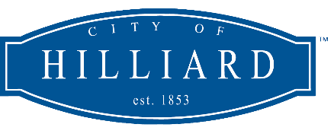

The City of Hilliard is an Equal Opportunity Employer

