THIS IS NOT A BILL – BILLS WILL BE MAILED IN JULY

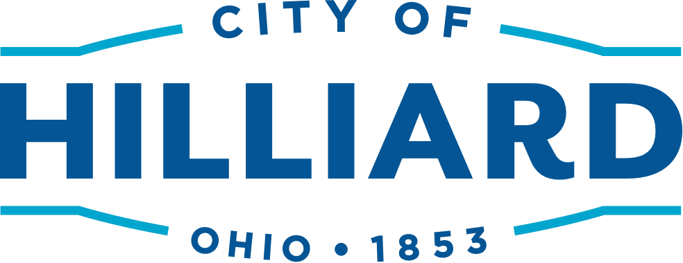
Hardship Discount Application
Trash/Recycling/Yard Waste Collection Services
July 1, 2024 – June 30, 2025

50% Discount for Semi-Annual Payments of $70.50
Must be applied for and approved annually.
Current applications accepted only through August 31, 2024

How to Qualify: As per the requirements of City Code 975.06 Collection Rates and Terms, applicants must own and occupy the property. Upon approval of your application your trash bill will be discounted accordingly.
Complete the section below and mail or drop off with all supporting documentation to the Finance Department, Trash Services, 3800 Municipal Way, Hilliard, OH 43026 between the hours of 8a.m.- 4p.m. Questions, please call 614-334-1209
Applicant’s Name: _______________________________________________________________________

Address: _________________________________________________________________________________

Telephone: ______________________________________________________________________________

Provide ALL of the Following:

- Medicaid (must be for applicant only)
- SNAP
Medicaid/Ohio Direct cards not accepted.
- Acceptable Proof of Coverage: Current Notice of Action/Approval letter from State of Ohio showing
name & date of coverage MUST be provided.

- HEAP
- PIPP
- Acceptable Proof of Coverage: Current approval letter from State of Ohio showing HEAP/PIPP services.

- Low Income Water/Sewer
  - Acceptable Proof of Coverage: Current City of Columbus water/sewer bill showing low-income service.

- Acceptable Proof of Address: Current utility bill (other than trash bill), driver’s license
- Acceptable Proof of Ownership: Current tax bill, Auditor’s Website Owner Information

_________________________________________________________________
Signature of Applicant Date
_______________________________________________ ___________________________________________
TO BE COMPLETED BY THE CITY OF HILLIARD

___________________________________ ____________
Signature of Finance Director Date

Account Updates Made: Initials:______ Date:________

