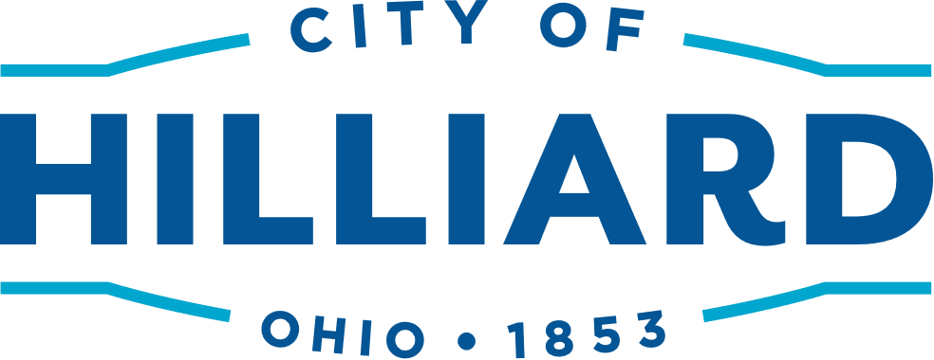
THIS IS NOT A BILL-BILLS WILL BE MAILED IN JULY

Senior Discount Application
Trash/Recycling/Yard Waste Collection Services
July 1, 2024 – June 30, 2025

If you already have the Senior Discount – no need to reapply. To verify call 614-334-1209

Semi-Annual Payments $126.90  (Due by August 31, 2024) | One Annual Discounted Payment of $243.80  (Must be paid in full by August 31, 2024)
How to Qualify: You must be 60 years old and own and occupy the residence. To receive the One Annual Discounted Payment option, you must be 60 years of age on or before August 31, 2024. Upon approval of your application, your bill will be discounted accordingly (a new bill will not be mailed). Anyone turning 60 after 8/31/24 can apply anytime for the Senior Discount and the discount will be applied on your next bill.
Complete the section below and mail or drop off with all supporting documentation to the Finance Department, Trash Services, 3800 Municipal Way, Hilliard OH 43026, between the hours of 8 a.m. – 4 p.m. Questions, please call 614-334-1209.
Applicant’s Name: _______________________________________________________________________

Address: _________________________________________________________________________________

Telephone: ______________________________________________________________________________

Provide ALL of the Following:
- Acceptable Proof of Age: driver’s license, passport, birth certificate or state ID
- Acceptable Proof of Address: current utility bill (other than trash bill) in applicant’s name and being mailed to service address, drivers license, or state ID
- Acceptable Proof of Ownership: current tax bill or Auditor’s website owner information

_____________________________________________________
Signature of Applicant Date

TO BE COMPLETED BY THE CITY OF HILLIARD

Hilliard approval: ________________________________________________________________
Finance Department Representative Date

Account Updates Made: Initials: _________ Date:____________

